SQL Database
PostgreSQL

Arun Balakrishnan
LinkedIn | GitHub

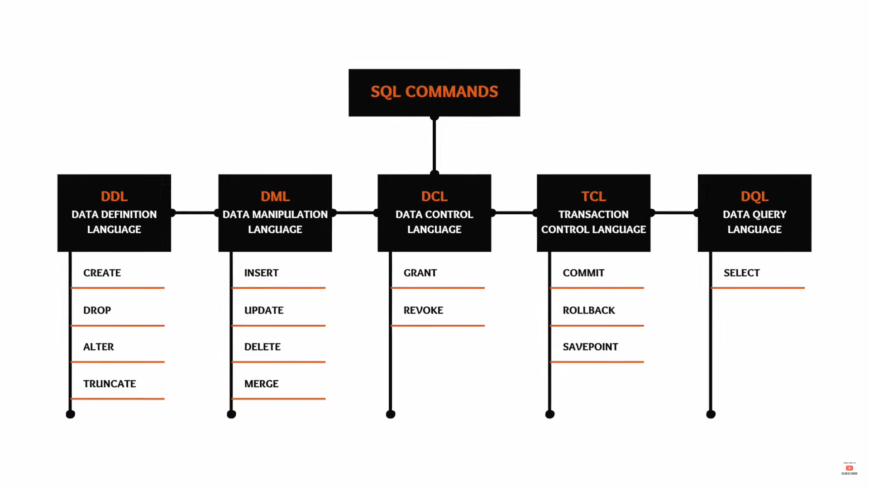
Data types
- Varchar
- Int
- Date
- Float
- Boolean
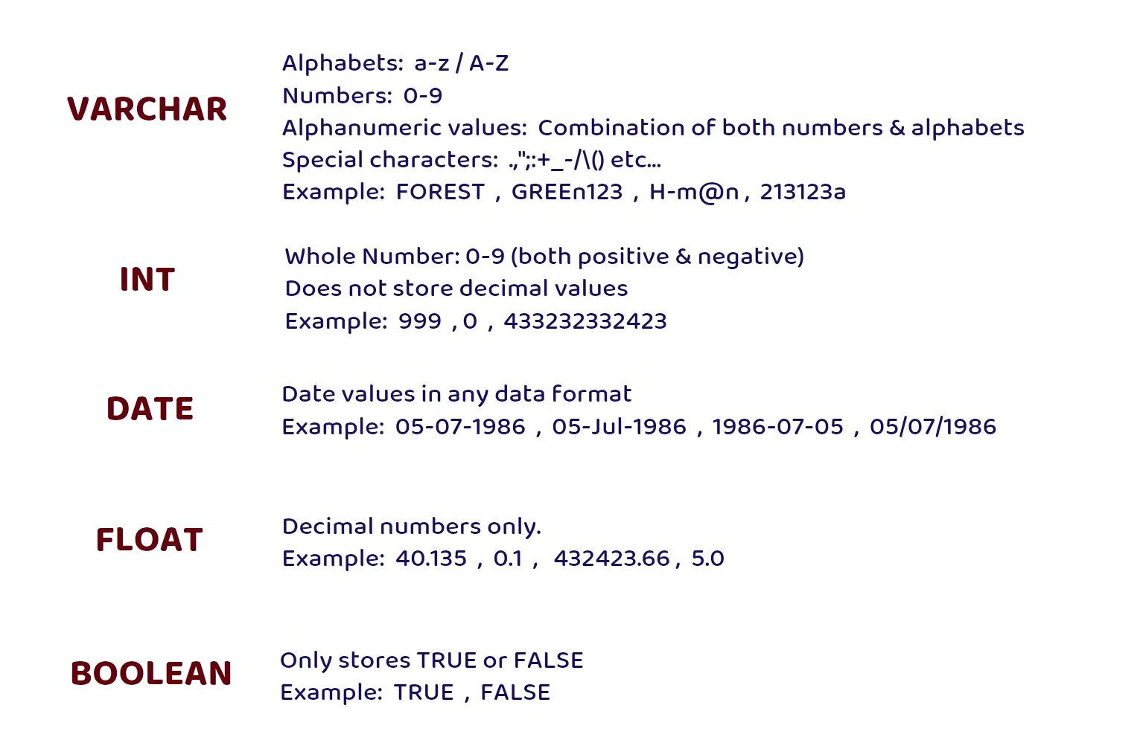

Eg:
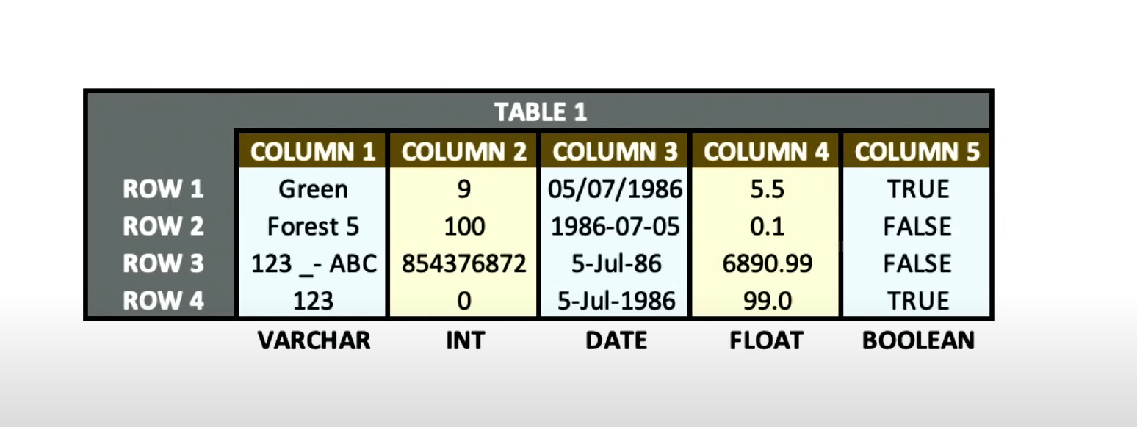

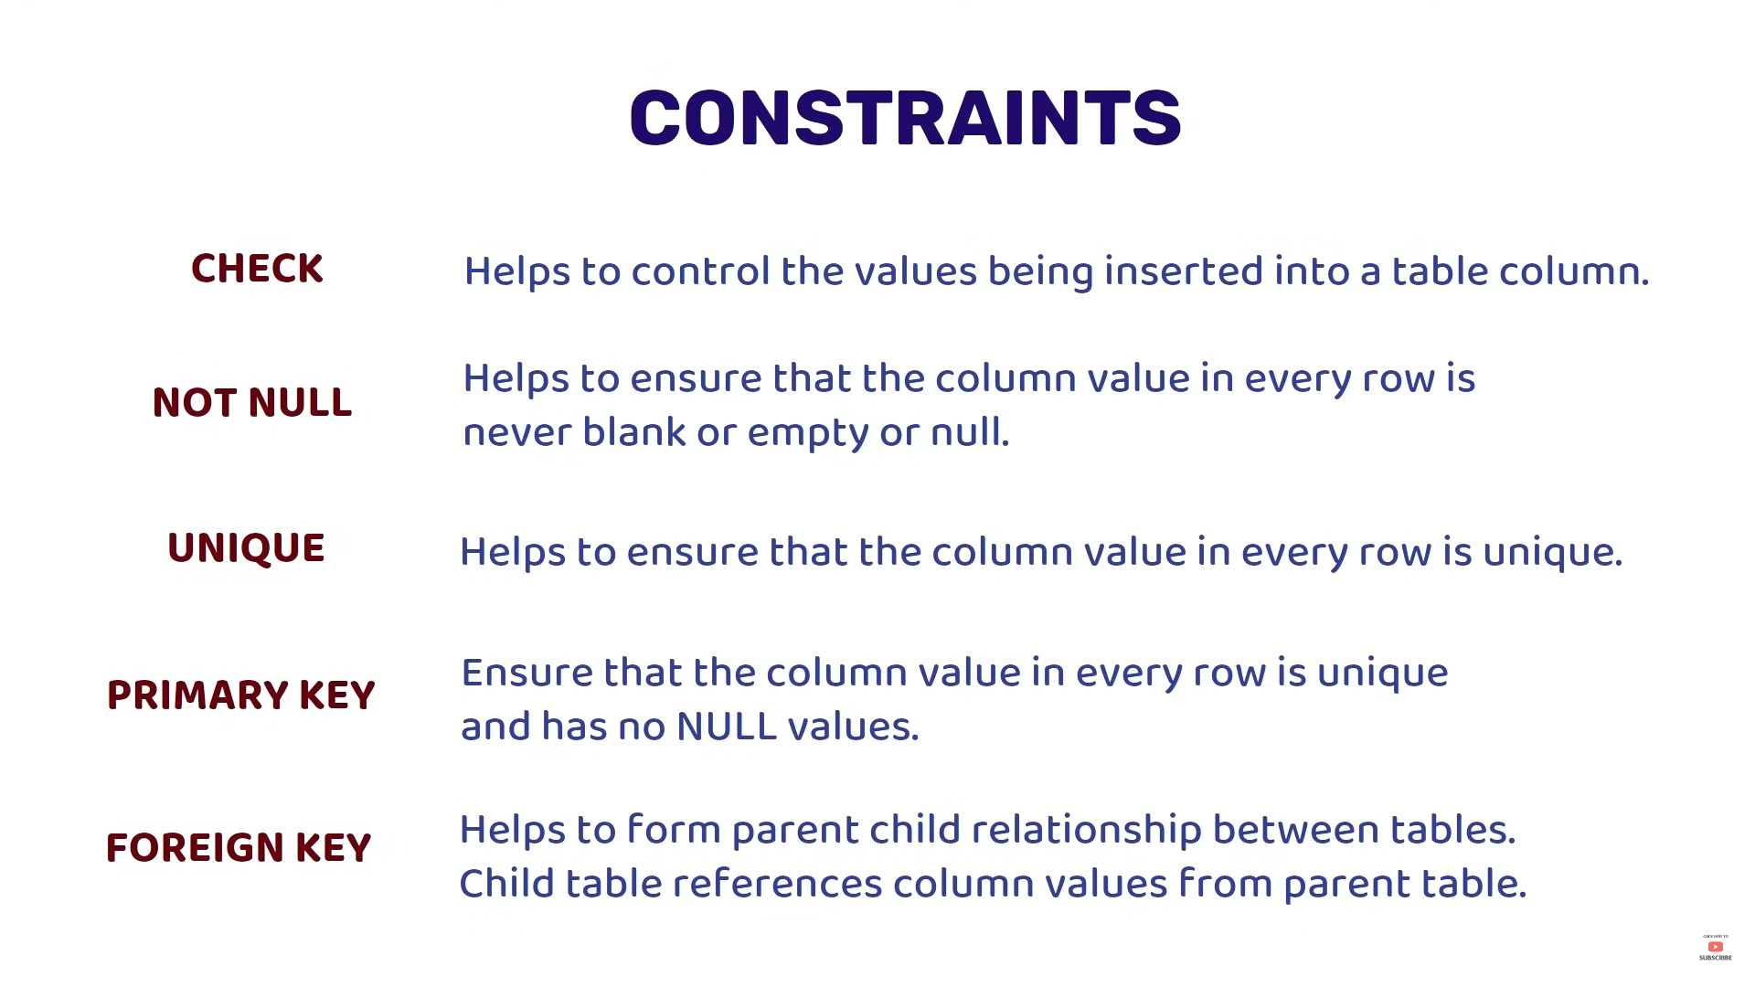

Two types of databases
- Relational
- Non Relational

Also known as
- SQL Database (data in Table format)
- Non SQL Database (data in document / as collection)

DDL
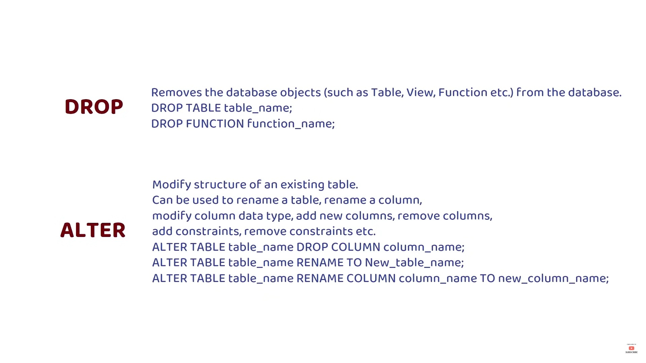
DML
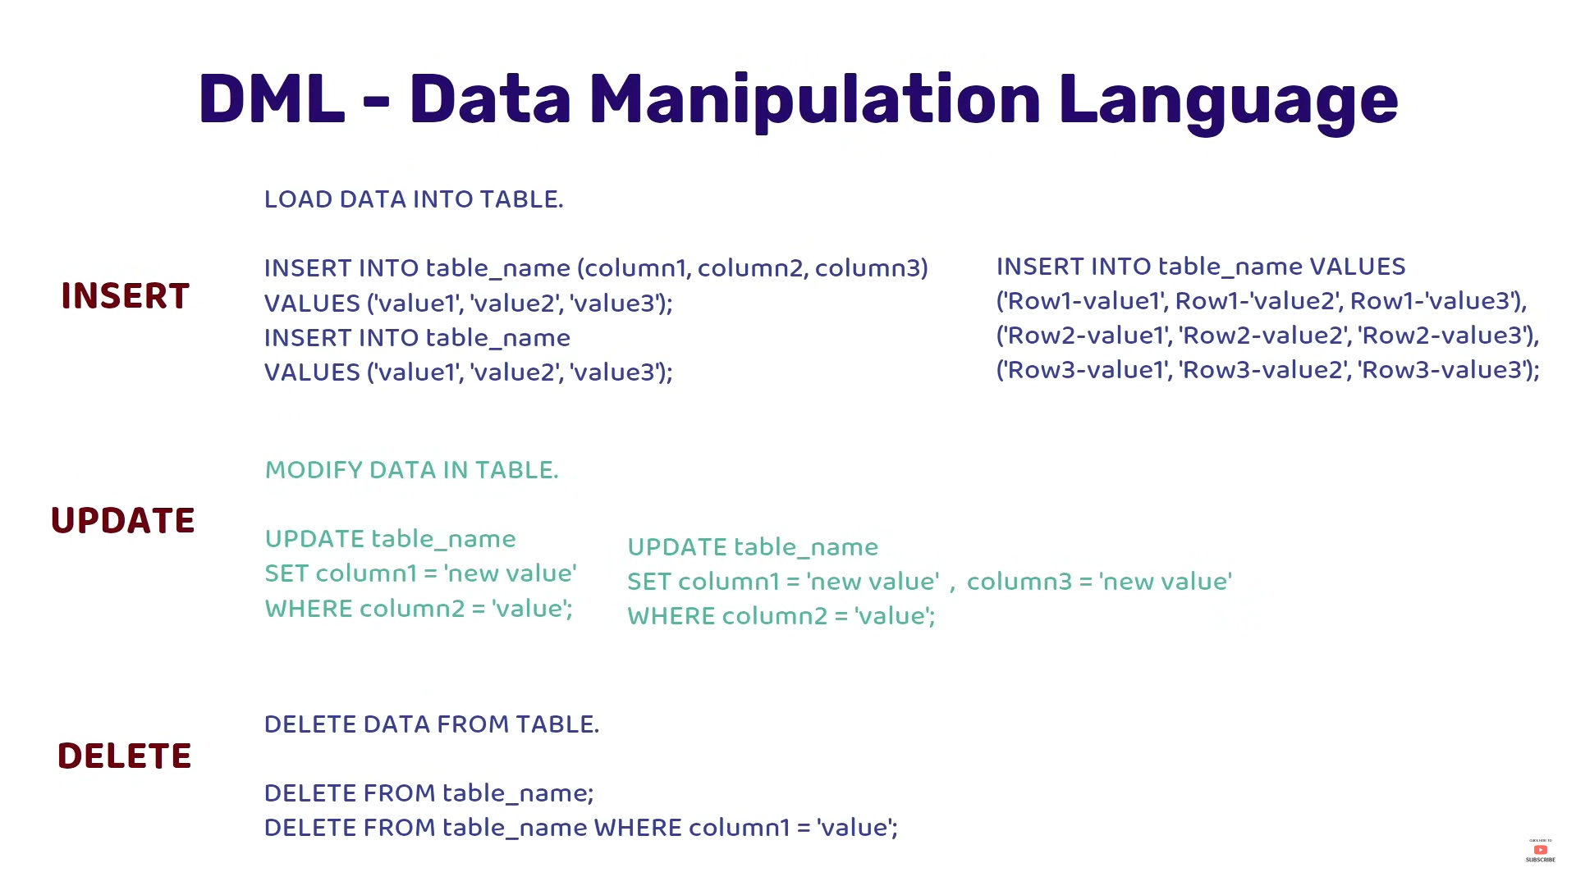
YouTube: SQL For Beginners Tutorial | Learn SQL in 4.2 Hours | 2021
YouTube: PostgreSQL Tutorial Full Course 2022

Data types
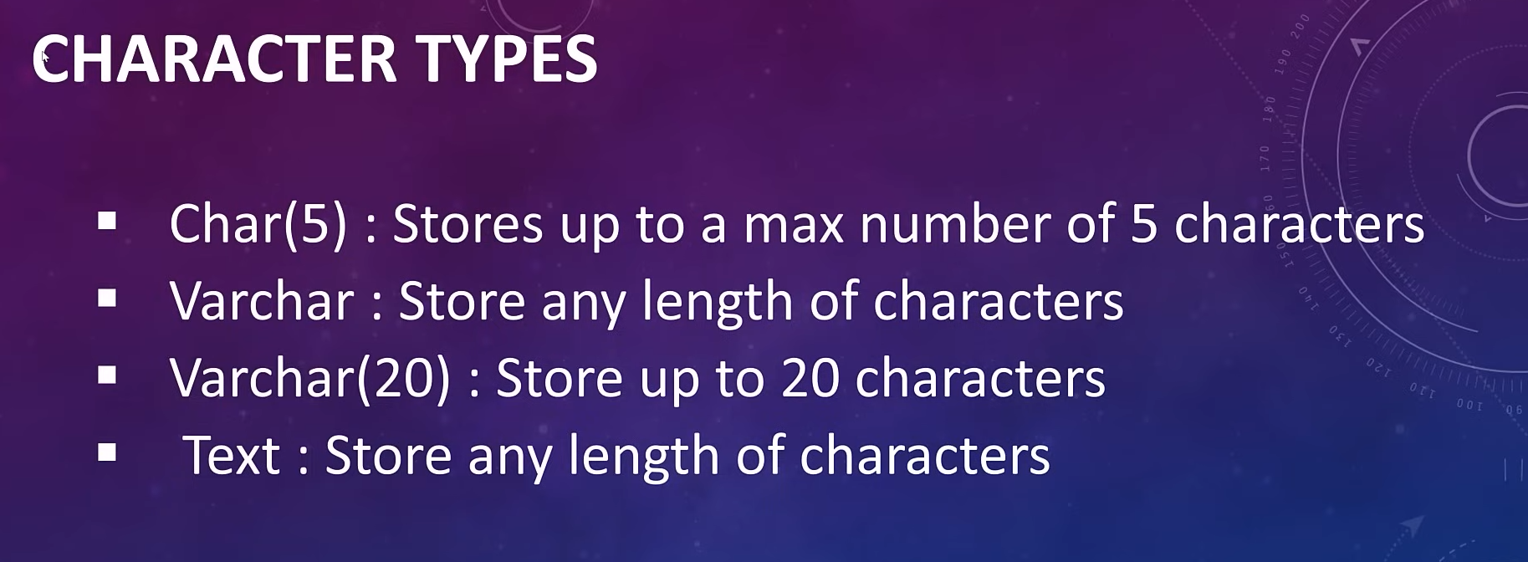

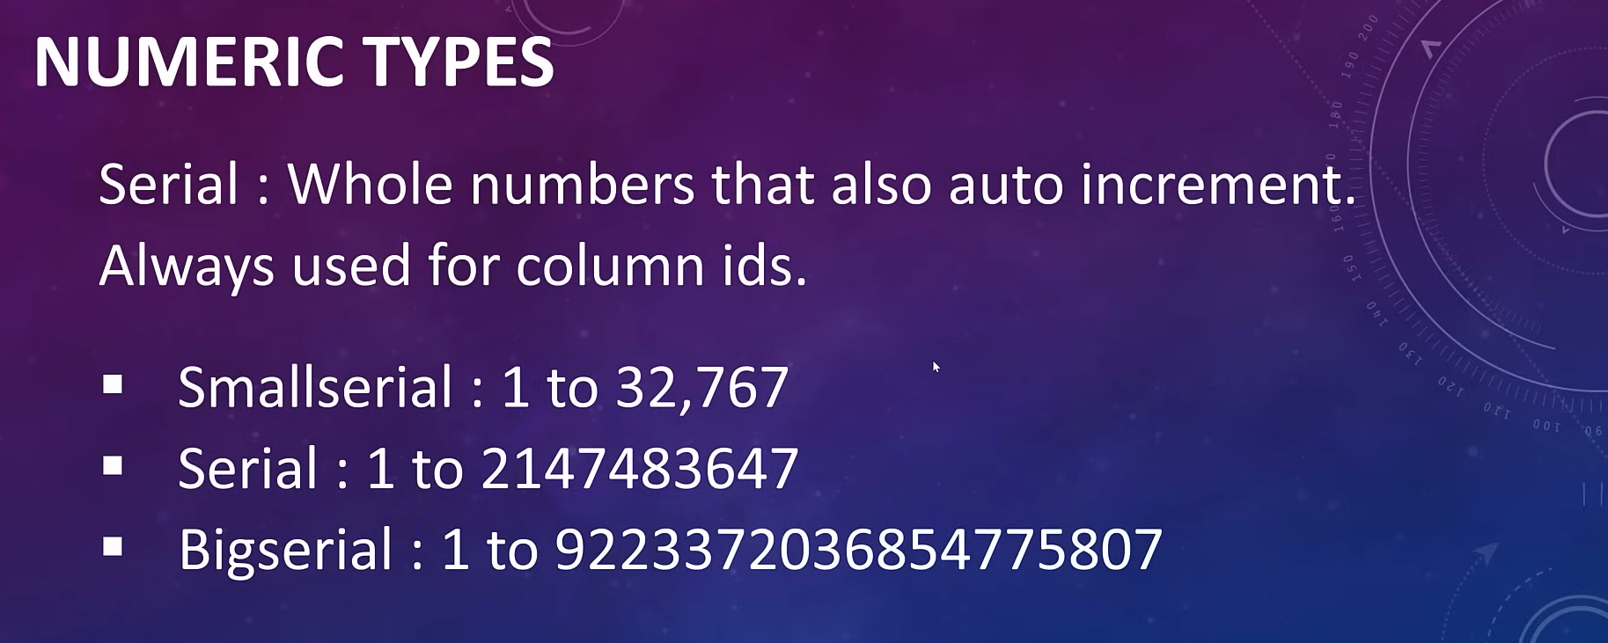

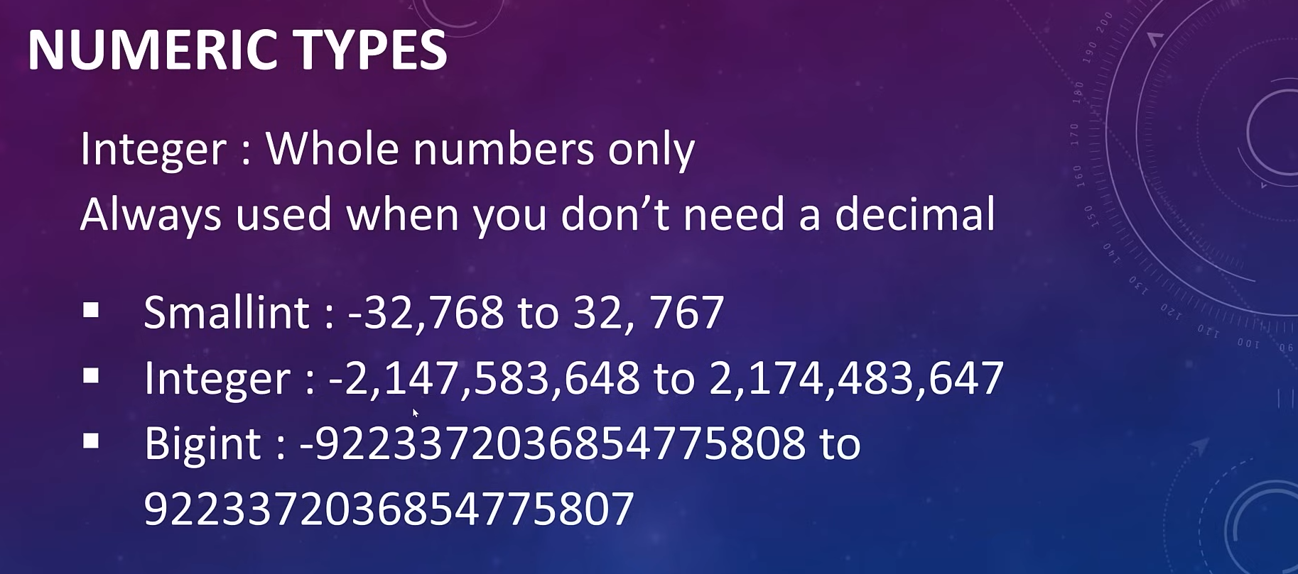
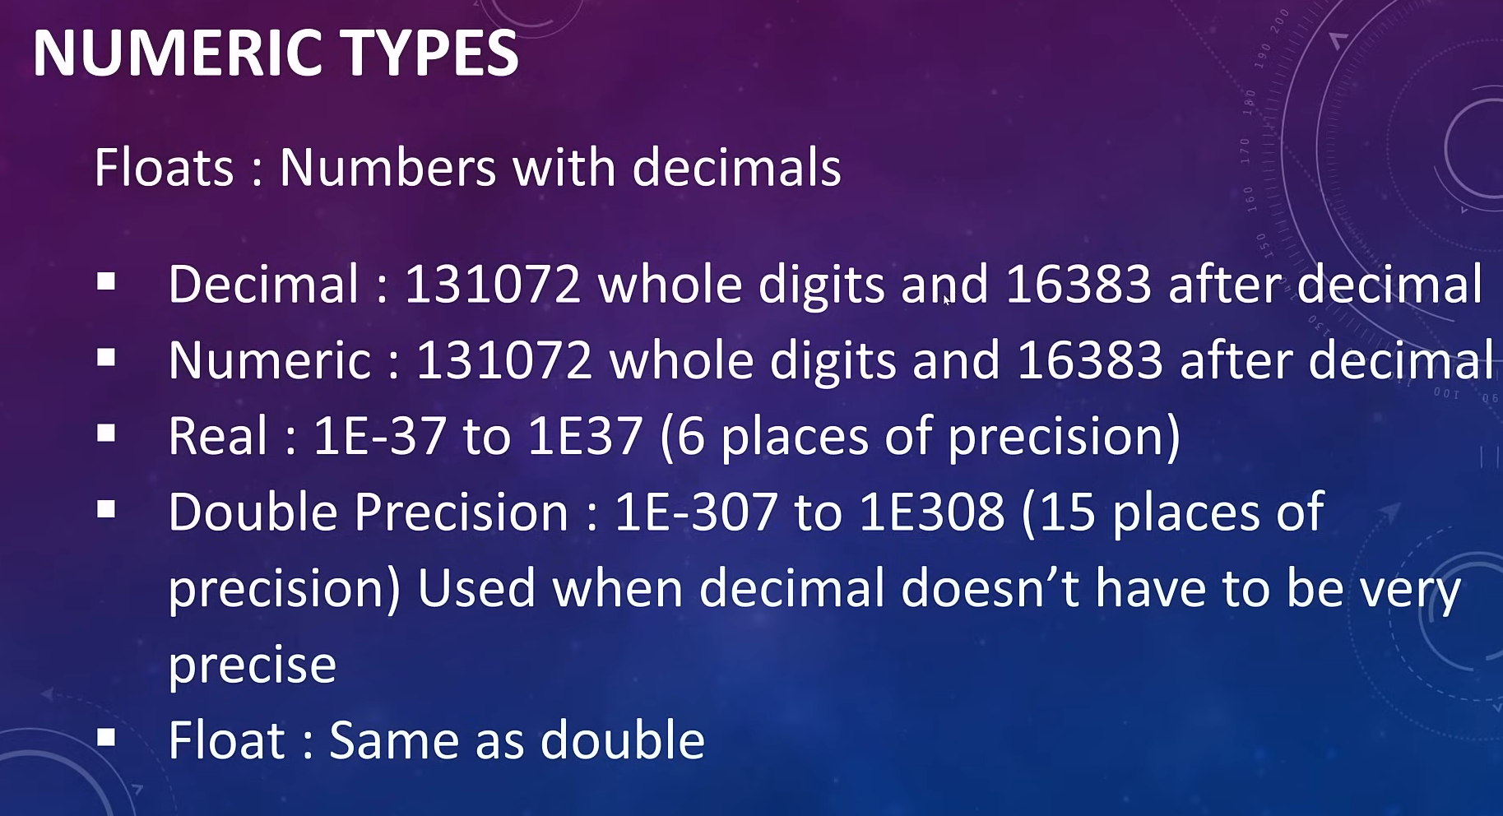

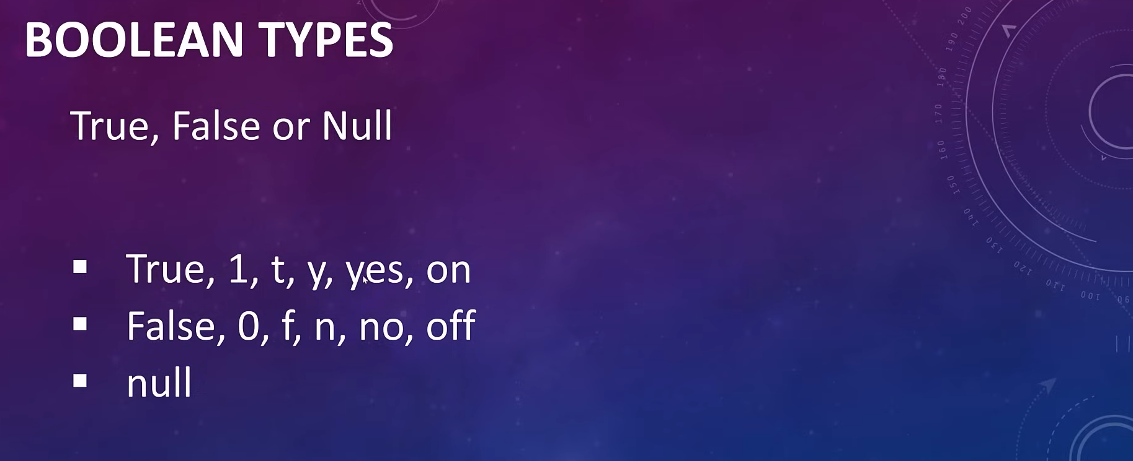

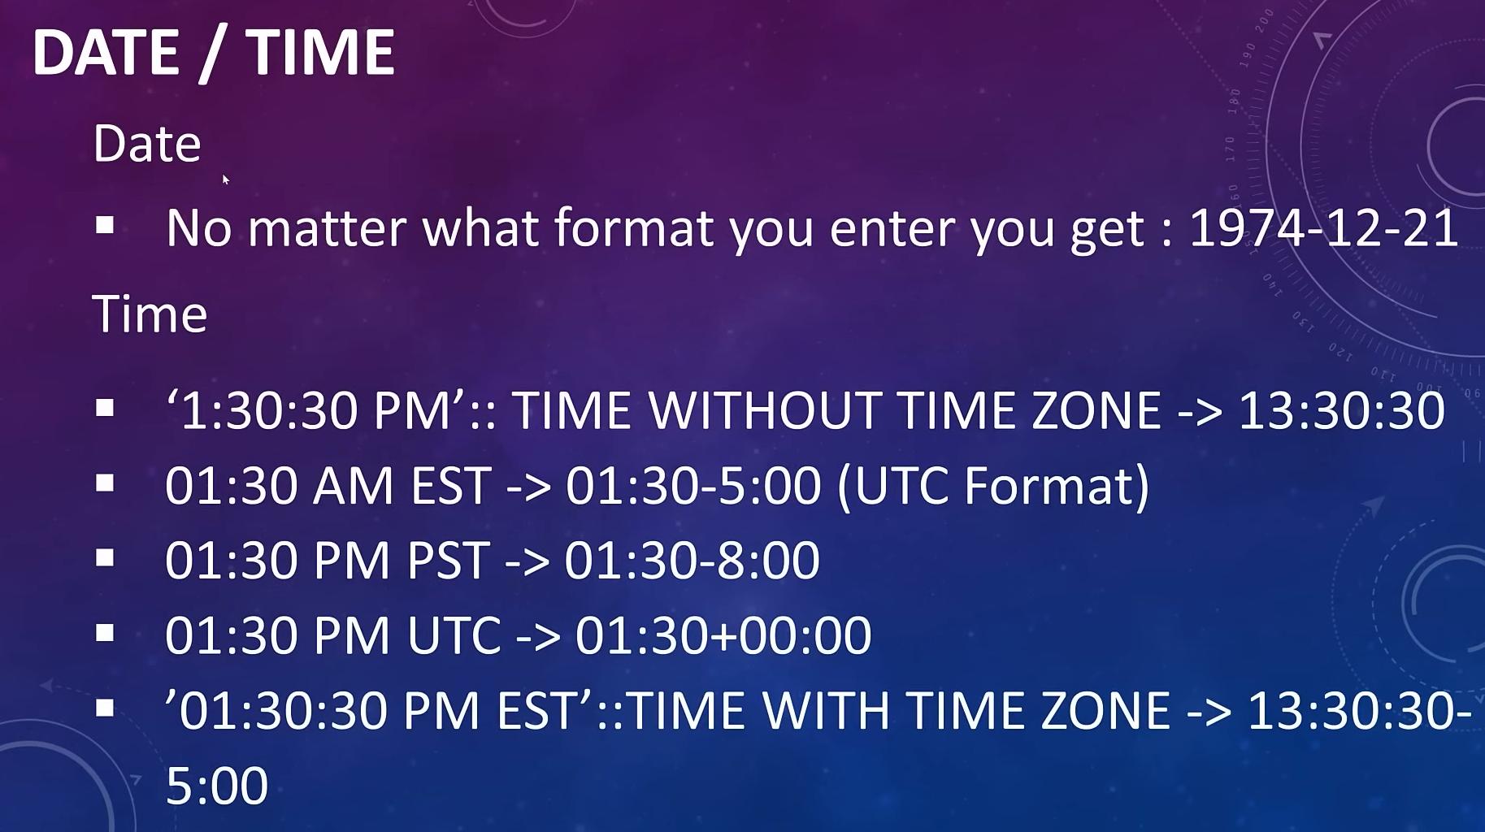

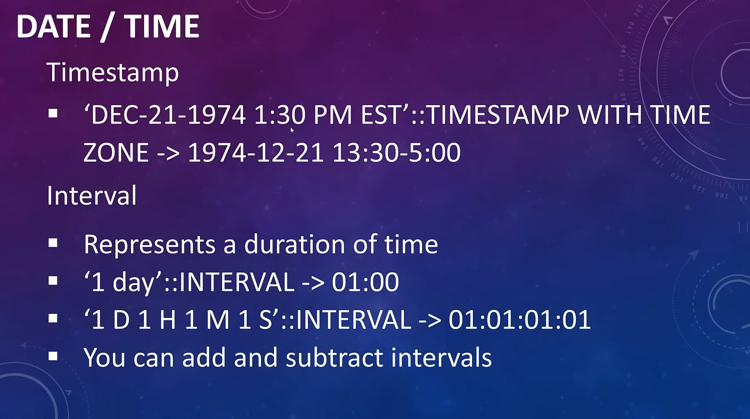

And a few more…..

Setting SQL

Linux: sudo -u postgres psql
Or: sudo -i -u postgres

psql -U postgres
Now use the password here which was used when installing postgres software

\l (Back slash and L)
To show default database

Create new database

CREATE DATABASE name;

CREATE DATABASE company;

To go to newly created database

\c name
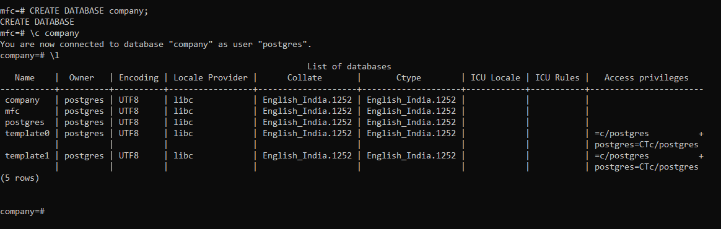

Create a table
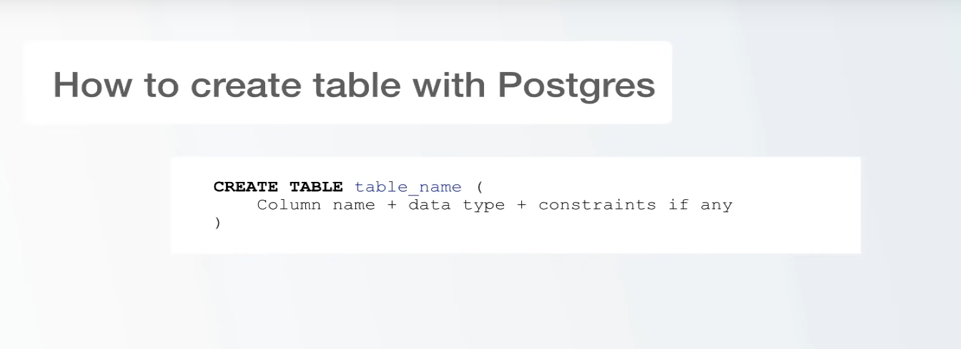

Then need to create a table.

CREATE TABLE person (

id SERIAL PRIMARY KEY,

first_name VARCHAR(50),

last_name VARCHAR(50),

gender VARCHAR(7),

date_of_birth DATE);
Here there is no constraints mentioned we can add some if we need such as “not null”

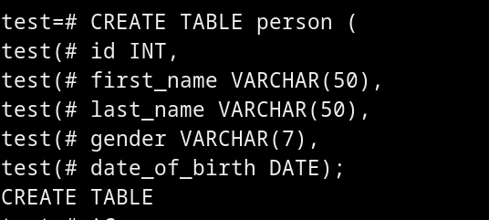

To See all the Tables in a database

\d

D - describe
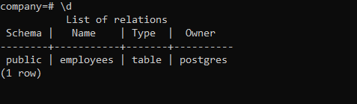

To see the table

\d employees

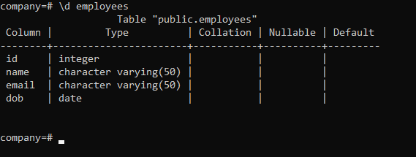

Create a table with constraints

CREATE TABLE person(

id BIGSERIAL NOT NULL PRIMARY KEY,

first_name VARCHAR(50) NOT NULL,

last_name VARCHAR(50) NOT NULL,

email VARCHAR(100),

gender VARCHAR(10) NOT NULL,

dob DATE NOT NULL);

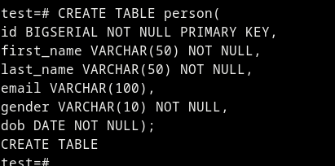

Here a table is created with the name employees with some “person”. Then it automatically creates another table with employees named “id” which is used to create a unique id for the elements.

The created table,

Deleting a table

DROP TABLE name;

Constrains
Constraints means there are some restrictions / must have things.

company(# id integer NOT NULL PRIMARY KEY

Insert Data to the table

Insert into employees (name,email, dob)

values (‘John’ , ‘john@gmail.com’, date ‘1990-01-01’);

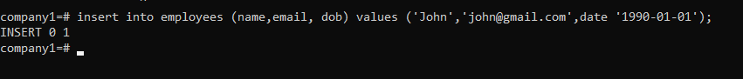

To see data of current table

SELECT * FROM employees;
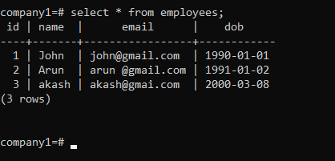

Get only a single column of detail

SELECT email FROM employees;

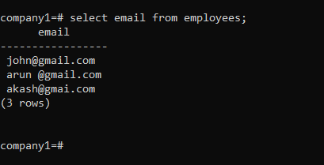

SELECT id, name, email FROM students;

This shows the name and email from the students table.
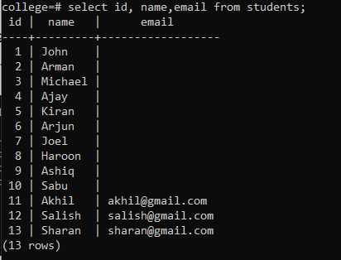

Display a column in Ascending order

SELECT * FROM employees ORDER BY name ASC;

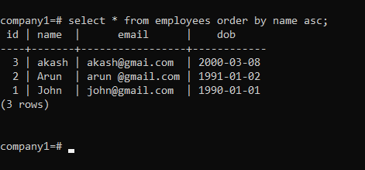

DESC for descending order.

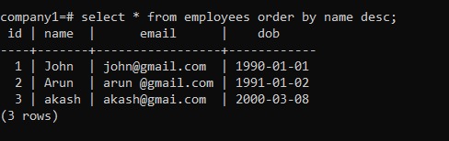

Sort with two columns
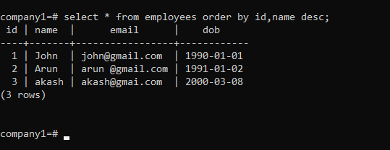
Here two columns are using for sorting id and name, First it sort based on id then if there similar id it again sort based on the name in desc;

Find Unique elements in a row (Repeating values shows once)

SELECT DISTINCT email FROM employees;

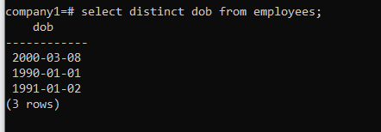

Adding column to a table

ALTER TABLE table_name

ADD color VARCHAR(255);

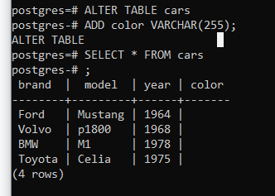

Here column color is added.

Adding data

UPDATE table_name SET gender = ’male’ WHERE id =1;
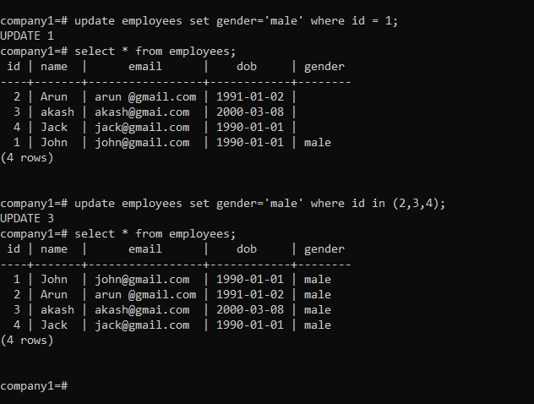

postgres=# UPDATE cars

postgres-# SET color = 'white', year = 1970

postgres-# WHERE brand = 'Toyota';

This will update two columns (color and year) together.

Filtering from a table

SELECT * FROM table_name WHERE column_heading = ‘Female’

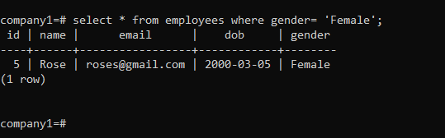

SELECT * FROM employees WHERE place = 'kannur' or place = 'iritty';

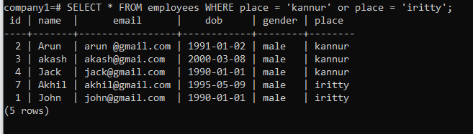

Another method

SELECT * FROM employees WHERE place IN ('kannur','iritty');
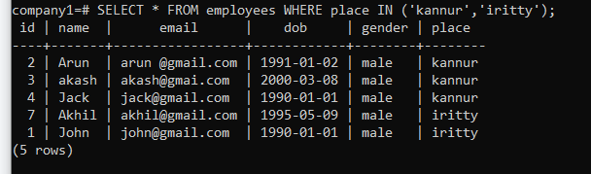

AND Operation for filtering data

select * from employees where gender= 'male'AND dob = '1990-01-01';

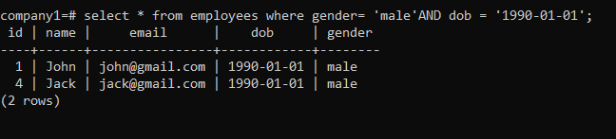

< less than

select * from employees where dob < '2000-01-01';

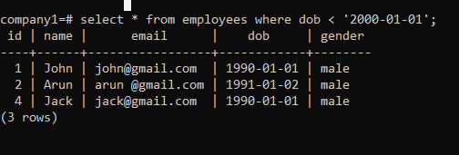

SELECT * FROM employees WHERE dob BETWEEN DATE ‘1990-01-01’ AND ‘2000-01-01’;

Show only certain number of rows

SELECT * FROM employees LIMIT 3;

This command shows first 3 lines of table from the whole company

Original table with all rows
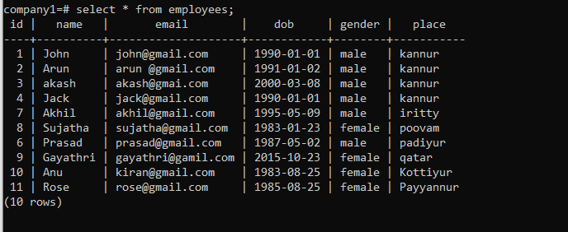

Output table
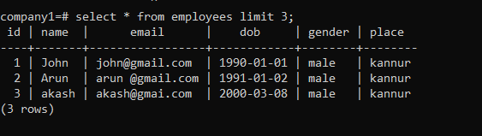

SELECT * FROM employees OFFSET 5 LIMIT 3;

This cmd allows to show rows from certain number row from
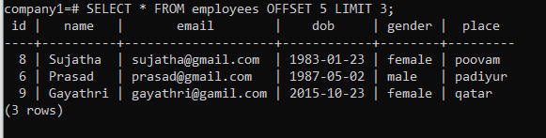
Here the table shows the 6th row and show 3 rows.

Another method

SELECT * FROM employees OFFSET 5 FETCH FIRST 2 ROWS ONLY;

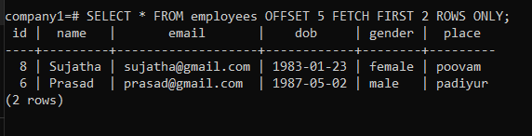

BETWEEN select

SELECT * FROM employees WHERE dob BETWEEN DATE '1990-01-01' AND '2000-01-01';

Here the table provides data between '1990-01-01' AND '2000-01-01';
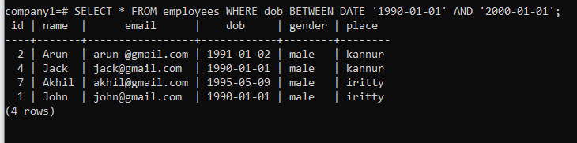

PATTERN (Filtering data using LIKE and ALIKE)

SELECT * FROM employees WHERE name LIKE '%a';

This shows names end with a

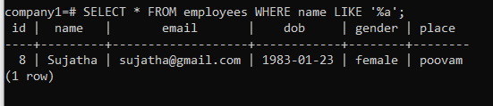

SELECT * FROM employees WHERE name LIKE 'A%';

This shows names starting with letter “A”
Here “A” is case sensitive

iLike
iLike is used to get both capital letters and small letters

SELECT * FROM employees WHERE name iLIKE 'A%';

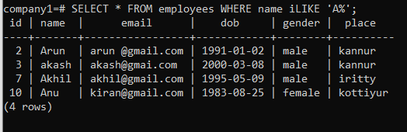

SELECT * FROM customers

WHERE city LIKE 'L_nd__';

Aggregate functions
In PostgreSQL (psql), aggregate functions are cool tools that let you perform operations on a bunch of rows and return a single result. They're handy for summarizing data. Eg: find average, max value, min value, sum etc.

SELECT SUM(column_name) FROM your_table;

SELECT AVG(column_name) FROM your_table;

SELECT MAX(column_name) FROM your_table;

SELECT place FROM employees GROUP BY PLACE;

This will group the place, but no repeating count there.

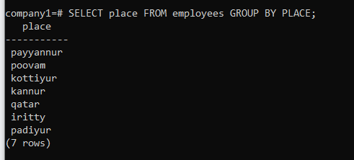

SELECT place, COUNT(*) FROM employees GROUP BY place;

This will give groups the data and give in a table format with count .

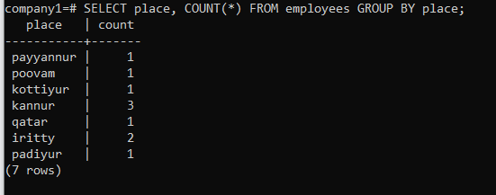

SELECT place, COUNT(*) FROM employees GROUP BY place ORDER BY COUNT;

This cmd groups the things and sort as well, it’s sorted in the base of count we can use name as well.
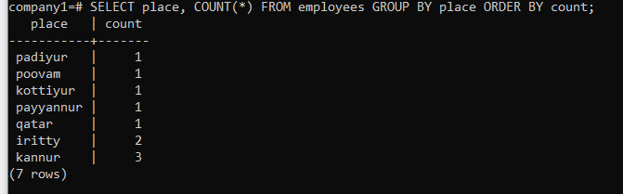

SELECT place, COUNT(*) FROM employees GROUP BY place HAVING COUNT(*)>1 ORDER BY COUNT;

This cmd will the repeating places with a conditions, here we applied place the repeating more than one.
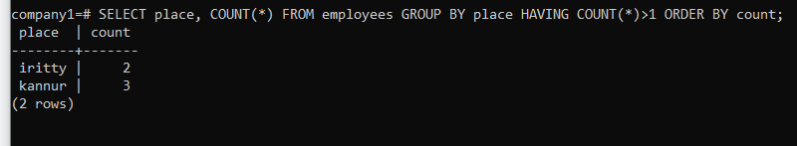

Max

SELECT max(salary) FROM employees;

This shows max salary, similarly we can use min as well

Main table with all data
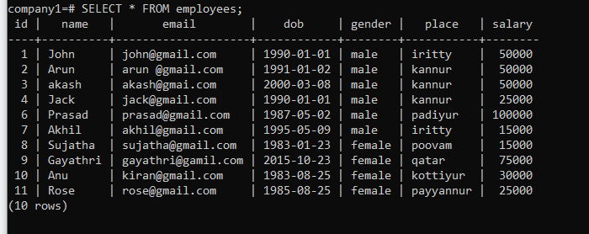

Output
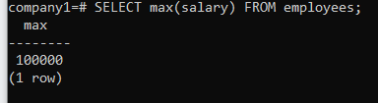

Average

SELECT avg(salary) FROM employees;

SELECT round(avg(salary)) FROM employees; This will give round figure

SUM

SELECT sum(salary) FROM employees;

There are many more aggregative functions in PSQL we’ve to visit official site for it.

Arithmetic Operations and Alias

We can do all basic arithmetic operations in n Postgres

SELECT 2+2;

COALESCE
Default table show when we asked to show two column from a table
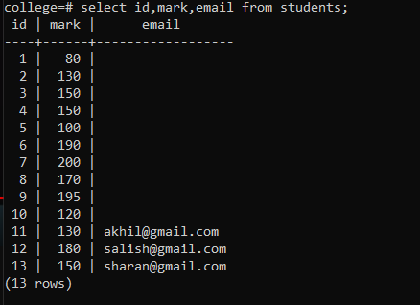
As we can see if there’s no data available in a column it simply shows a null, to get a message we can use COALESCE

SELECT id, name, COALESCE(email, ‘email not found’) FROM students;

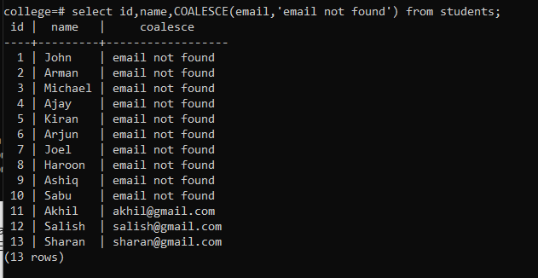

Timestamps and Dates

select now();
This cmd will give the current date and time.
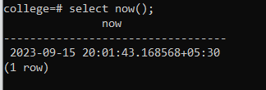

select now()::time;

This cmd will time only.

select extract (year from now());

This will give year.

SELECT NOW() + INTERVAL '10 YEARS';
This will give date and time after 10 year.
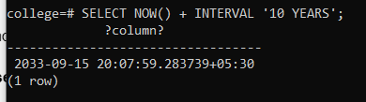
Here we can use subtract as well for getting before 10 year.

Constraints
Constraints mean certain rules.
PRIMARY KEY
Primary key is used to set a unique id to each element to identify uniquely, it may be a single column of data or combination of column data.

Aliases
SQL aliases are used to give a table, or a column in a table, a temporary name. Aliases are often used to make column names more readable. An alias only exists for the duration of that query.

SELECT customer_name AS people

FROM customers;

Concatenate Columns
The AS keyword is often used when two or more fields are concatenated into one. To concatenate two fields use ||.

SELECT product_name || unit AS product

FROM products;

Note: In the result of the example above we are missing a space between product_name and unit. To add a space when concatenating, use || ' ' ||.

SELECT product_name || ' ' || unit AS product

FROM products;

When
When command is like if statement in other programming languages

SELECT staff_id, salary,

CASE

WHEN salary >= 10000 THEN 'High Salary'

WHEN salary BETWEEN 5000 AND 10000 THEN 'Average Salary'

WHEN salary < 5000 THEN 'Too Low'

END AS RANGE

FROM staff_salary

ORDER BY salary DESC;

Inner Join

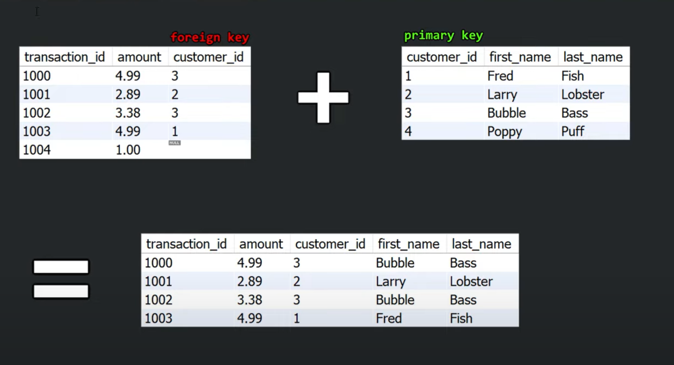
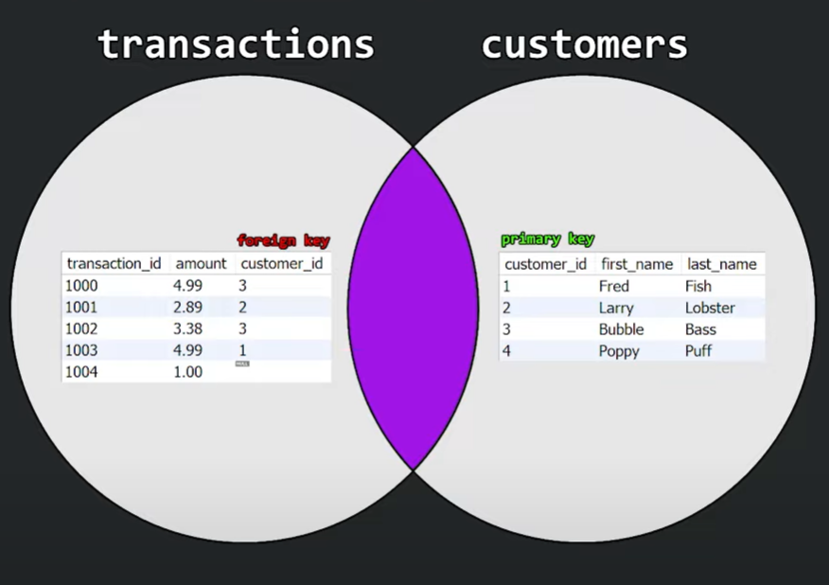

SELECT * FROM transactions

INNER JOIN customers

ON transaction.customer_id = customers.customer_id;

Here “transactions is the left table and customers is the right table. And we are checking which column is common between two tables. Here customer_id is common in both tables, so we are combining based on customer_id. It will join two columns based on this. If there's no common thing for both, we can't join.

Output
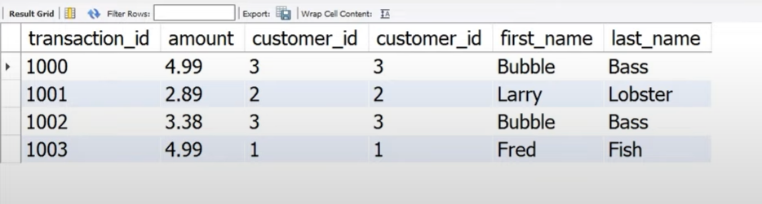

Left Join
On the left join every data on the left table will show, however only matching data from the right table will be shown.

SELECT *

FROM transactions LEFT JOIN customers

ON transaction.customer_id = customers.customer_id;

Right Join

SELECT *

FROM transactions RIGHT JOIN customers

ON transaction.customer_id = customers.customer_id;

3 Table join

SELECT e.emp_name, d.dept_name, m.manager_name FROM

employee e LEFT JOIN department d

ON e.dept_id = d.dept_id

INNER JOIN manager m ON m.manager_id = e.manager_id

FULL OUTER JOIN

SELECT *

FROM transactions FULL JOIN customers

ON transaction.customer_id = customers.customer_id;

UNION
Union command is used to show combine two tables together. The number of columns should be the same in both tables.

SELECT * FROM staff

UNION

SELECT * FROM student;

In normal Union operator it won’t include duplicate columns, but if we need to include duplicates need to UNION ALL can be used.

CREATE TABLE transactions (

transaction_id SERIAL PRIMARY KEY,

amount DECIMAL(5, 2),

customer_id INT,

order_date DATE,

);

Group By
The GROUP BY clause groups rows that have the same values into summary rows, like "find the number of customers in each country".

The GROUP BY clause is often used with aggregate functions like COUNT(), MAX(), MIN(), SUM(), AVG() to group the result-set by one or more columns.

SELECT COUNT(customer_id), country

FROM customers

GROUP BY country;

Adjusting the decimal points

SELECT AVG(price)::NUMERIC(10,2)

FROM products;

Concatenate
This is used to concatenate two columns of contents

SELECT product_name || unit AS product

FROM products;

Here there will not be any space between contents from two tables. So we can use another command to fix it.

SELECT product_name || ' ' || unit AS product

FROM products;

Inside the ‘ ‘ we can add anything we want.

Cross Join
The CROSS JOIN keyword matches ALL records from the "left" table with EACH record from the "right" table.

That means that all records from the "right" table will be returned for each record in the "left" table.

This way of joining can potentially return a very large table, and you should not use it if you do not have to.

Let's look at an example using our dummy test products table:

SELECT testproduct_id, product_name, category_name

FROM testproducts

CROSS JOIN categories;

UNION
The UNION operator is used to combine the result-set of two or more queries.
The queries in the union must follow these rules:

They must have the same number of columns
The columns must have the same data types
The columns must be in the same order

UNION vs UNION ALL
With the UNION operator, if some rows in the two queries return the exact same result, only one row will be listed, because UNION selects only distinct values.

Use UNION ALL to return duplicate values.

Let's make some changes to the queries, so that we have duplicate values in the result:

SELECT product_id

FROM products

UNION

SELECT testproduct_id

FROM testproducts

ORDER BY product_id;

GROUP BY With JOIN
The following SQL statement lists the number of orders made by each customer:

SELECT customers.customer_name, COUNT(orders.order_id)

FROM orders

LEFT JOIN customers ON orders.customer_id = customers.customer_id

GROUP BY customer_name;

HAVING
The HAVING clause was added to SQL because the WHERE clause cannot be used with aggregate functions.

Aggregate functions are often used with GROUP BY clauses, and by adding HAVING we can write conditions like we do with WHERE clauses.

ALTER COLUMN

ALTER TABLE cars

ALTER COLUMN year TYPE VARCHAR(4);

This cmd changes a column (headings) data type.

Change Maximum Allowed Characters

ALTER TABLE cars

ALTER COLUMN color TYPE VARCHAR(30);

This will change the maximum allowed characters

DROP COLUMN

ALTER TABLE cars

DROP COLUMN color;

This will delete the column named color

The DELETE Statement
The DELETE statement is used to delete existing records in a table.
To to delete the record(s) where brand is 'Volvo', use this statement:

DELETE FROM cars

WHERE brand = 'Volvo';

Delete all records in the cars table:

DELETE FROM cars;

There is another method as well to delete all the records in the current table

TRUNCATE TABLE cars;

PostgreSQL Operators

= Equal to
< Less than
> Greater than
<= Less than or equal to
>= Greater than or equal to
<> Not equal to
!= Not equal to
LIKE Check if a value matches a pattern (case sensitive)
ILIKE Check if a value matches a pattern (case insensitive)
AND Logical AND
OR Logical OR
IN Check if a value is between a range of values
BETWEEN Check if a value is between a range of values
IS NULL Check if a value is NULL
NOT Makes a negative result e.g. NOT LIKE, NOT IN, NOT BETWEEN

How to use it?

SELECT * FROM cars

WHERE brand = 'Volvo';

SELECT * FROM cars

WHERE model < 1975;

LIKE

The LIKE operator is used when you want to return all records where a column is equal to a specified pattern.

The pattern can be an absolute value like 'Volvo', or with a wildcard that has a special meaning.

There are two wildcards often used in conjunction with the LIKE operator:

Return all records where the model STARTS with a capital 'M':

SELECT * FROM cars

WHERE model LIKE 'M%';

LIKE is case sensitive so we can use ILIKE

AND

SELECT * FROM cars

WHERE brand = 'Volvo' AND year = 1968;

IN
The IN operator is used when a column's value matches any of the values in a list:
Return all records where the brand is present in this list: ('Volvo', 'Mercedes', 'Ford'):

SELECT * FROM cars

WHERE brand IN ('Volvo', 'Mercedes', 'Ford');

BETWEEN

SELECT * FROM cars

WHERE year BETWEEN 1970 AND 1980;

Normalisation
Normalization in PostgreSQL (often abbreviated as "psql") refers to the process of organizing and structuring a relational database to reduce data redundancy and improve data integrity. The goal of normalization is to ensure that data is stored efficiently without unnecessary duplication while maintaining data consistency. It is essential for maintaining data quality and preventing anomalies like update anomalies, insert anomalies, and delete anomalies.
Normalization is typically achieved by dividing a database into multiple related tables and establishing relationships between them using foreign keys. There are different normal forms, with each successive normal form (from 1NF to 5NF) having stricter rules for organizing data.
Here are the first three normal forms (1NF, 2NF, and 3NF) and how they relate to PostgreSQL:

1. **First Normal Form (1NF):** In 1NF, each column in a table must hold atomic (indivisible) values. There should be no repeating groups or arrays in a column.
For example, consider a table for storing customer orders. Instead of having a single "Products" column with a list of products, you would create a separate table for products and establish a relationship between the orders and products using foreign keys.

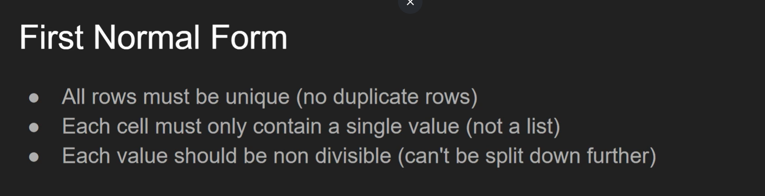

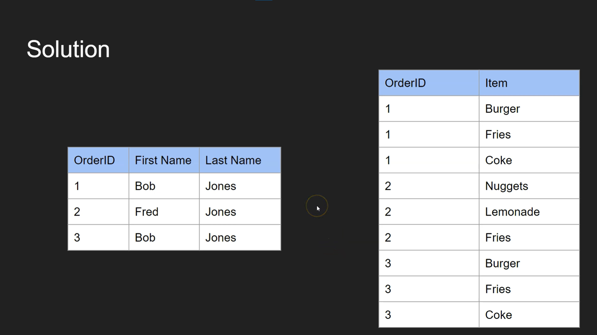
2. **Second Normal Form (2NF):** In 2NF, a table must meet the requirements of 1NF, and all non-key attributes (columns) must be fully functionally dependent on the entire primary key.
In PostgreSQL, you achieve this by breaking tables down into smaller tables that represent specific entities and their attributes. This ensures that each table has a clear primary key and attributes that are dependent on that key.
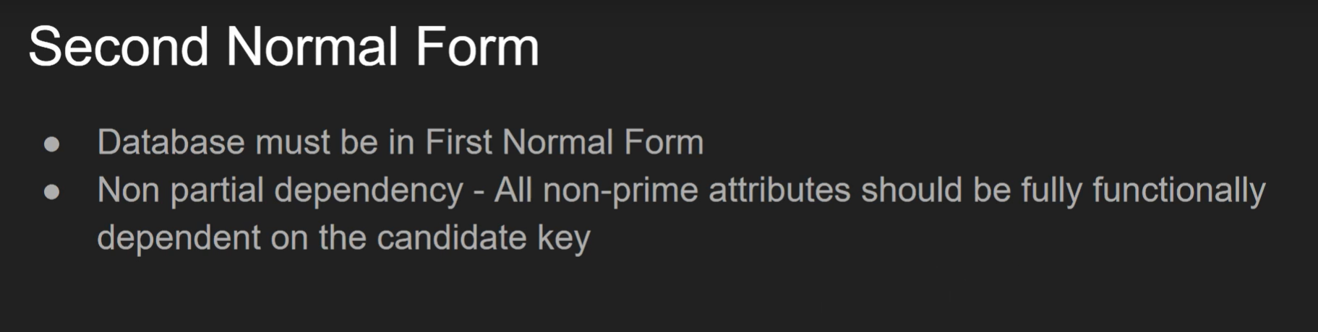
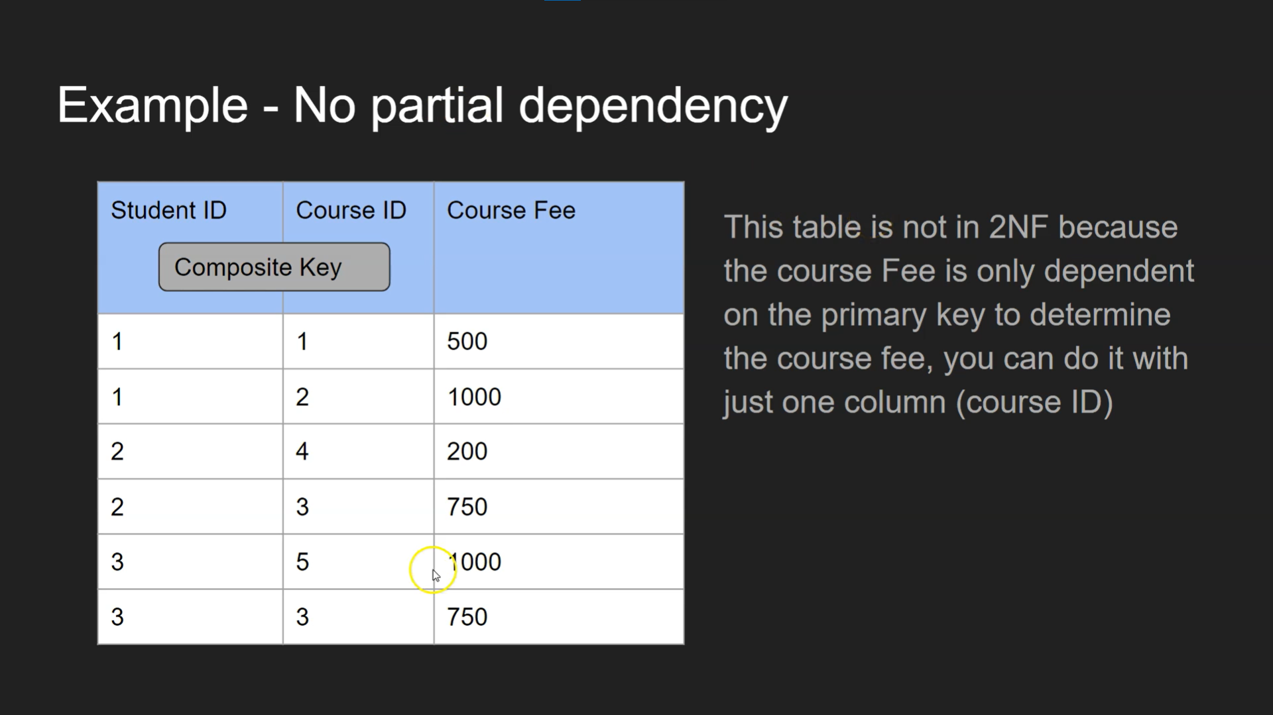

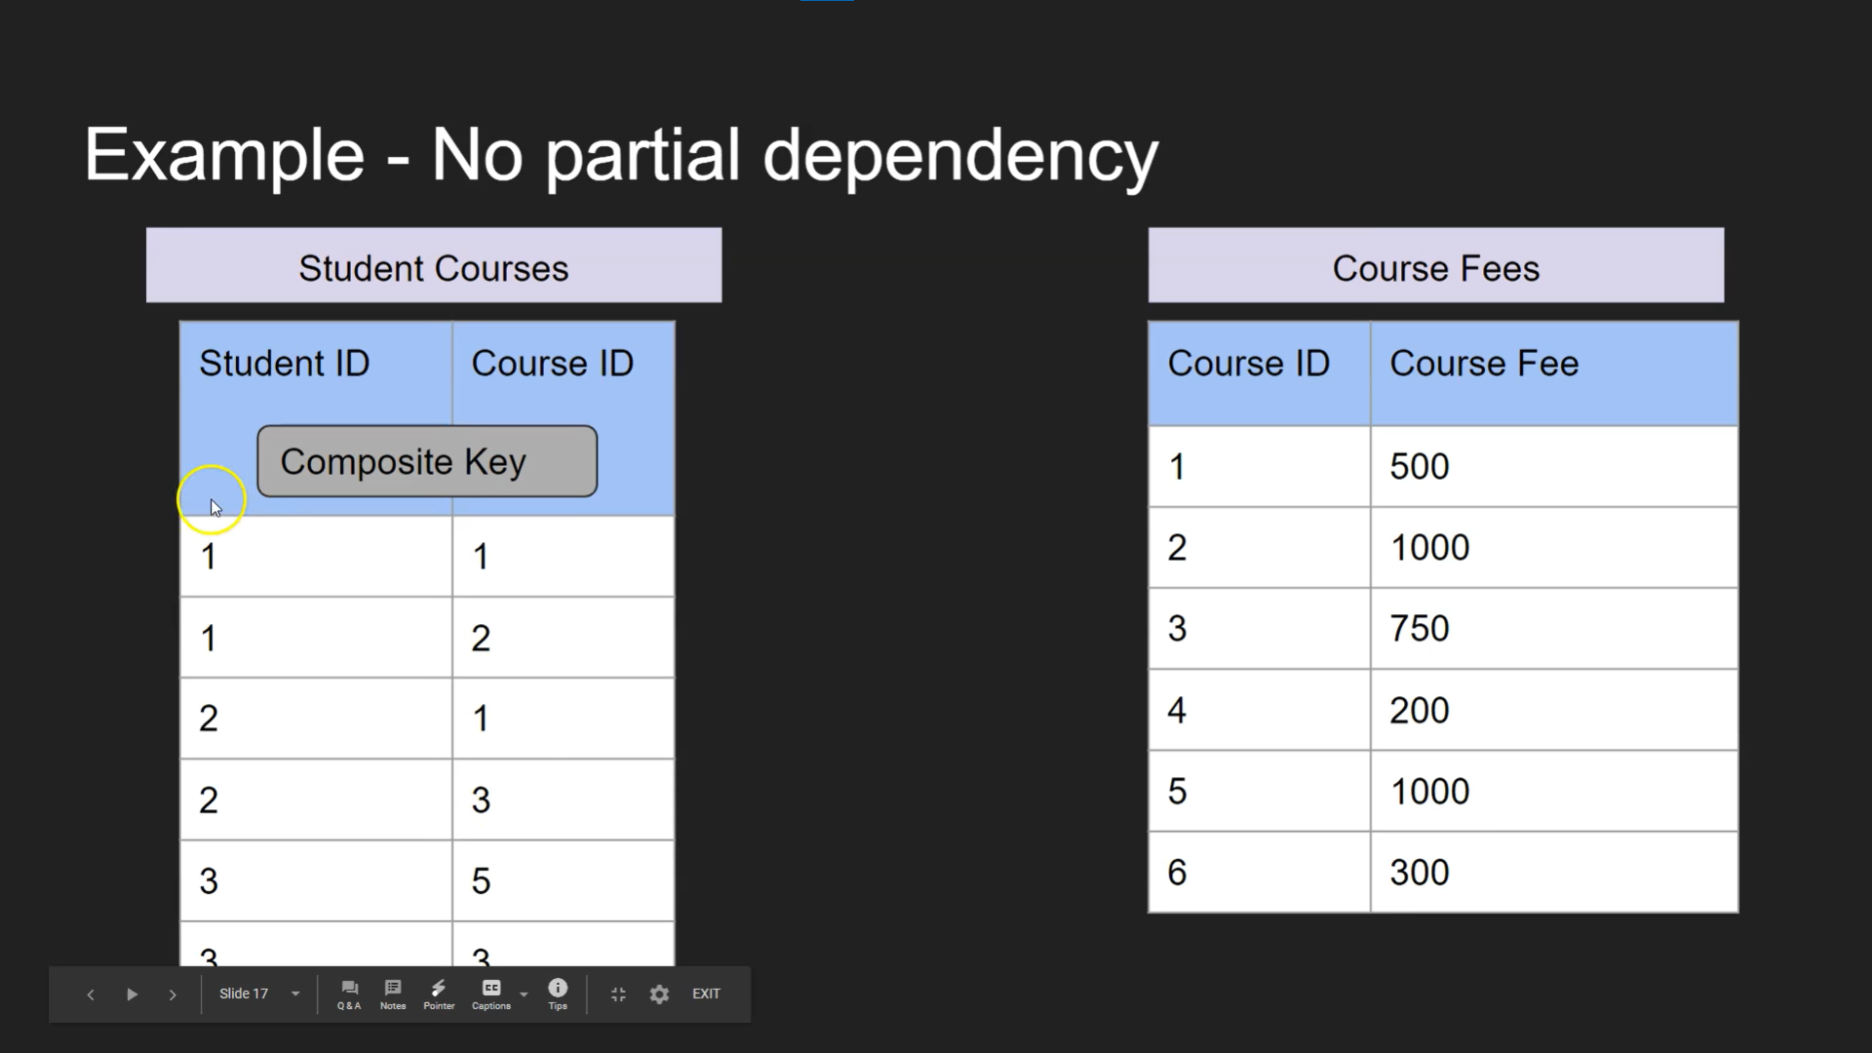
3. **Third Normal Form (3NF):** In 3NF, a table must meet the requirements of 2NF, and there should be no transitive dependencies. Transitive dependencies occur when non-key attributes depend on other non-key attributes.
To achieve 3NF, you might further break down tables and separate attributes that depend on other non-key attributes into their own tables. Here's an example in PostgreSQL syntax:
In this example, data is normalized into multiple tables (customers, products, orders, and order_details), and foreign keys establish relationships between them. This structure follows the principles of normalization to reduce data redundancy and maintain data integrity.

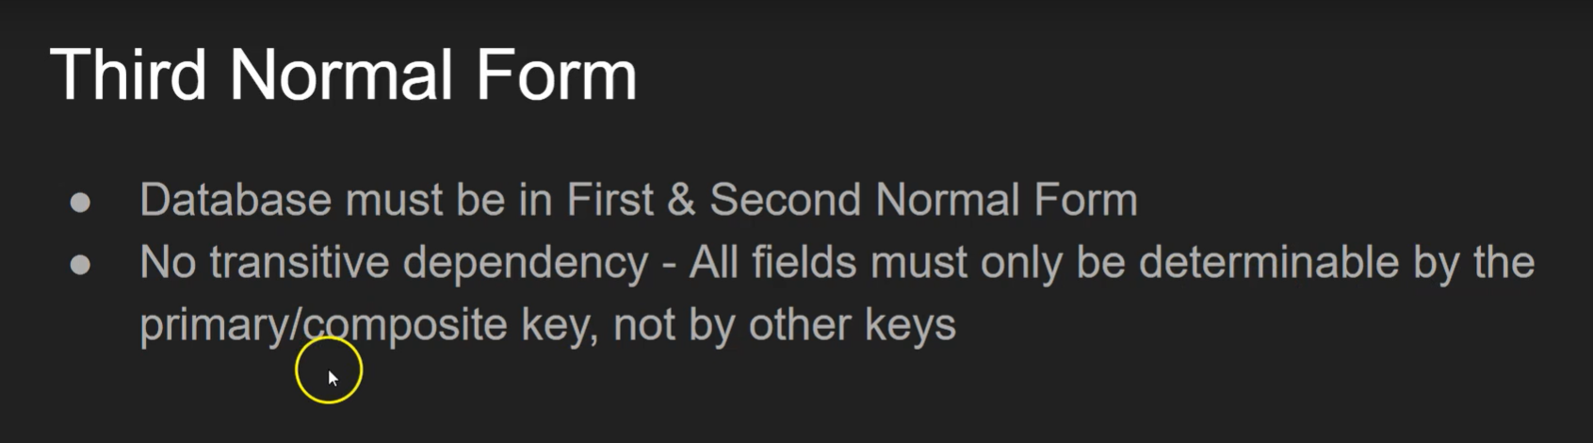

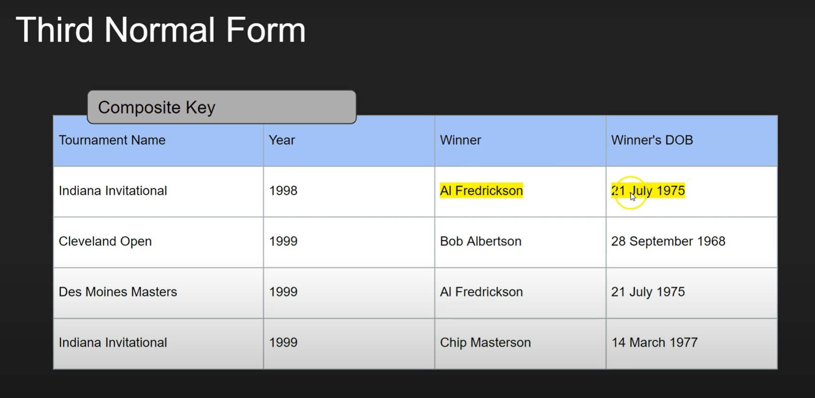
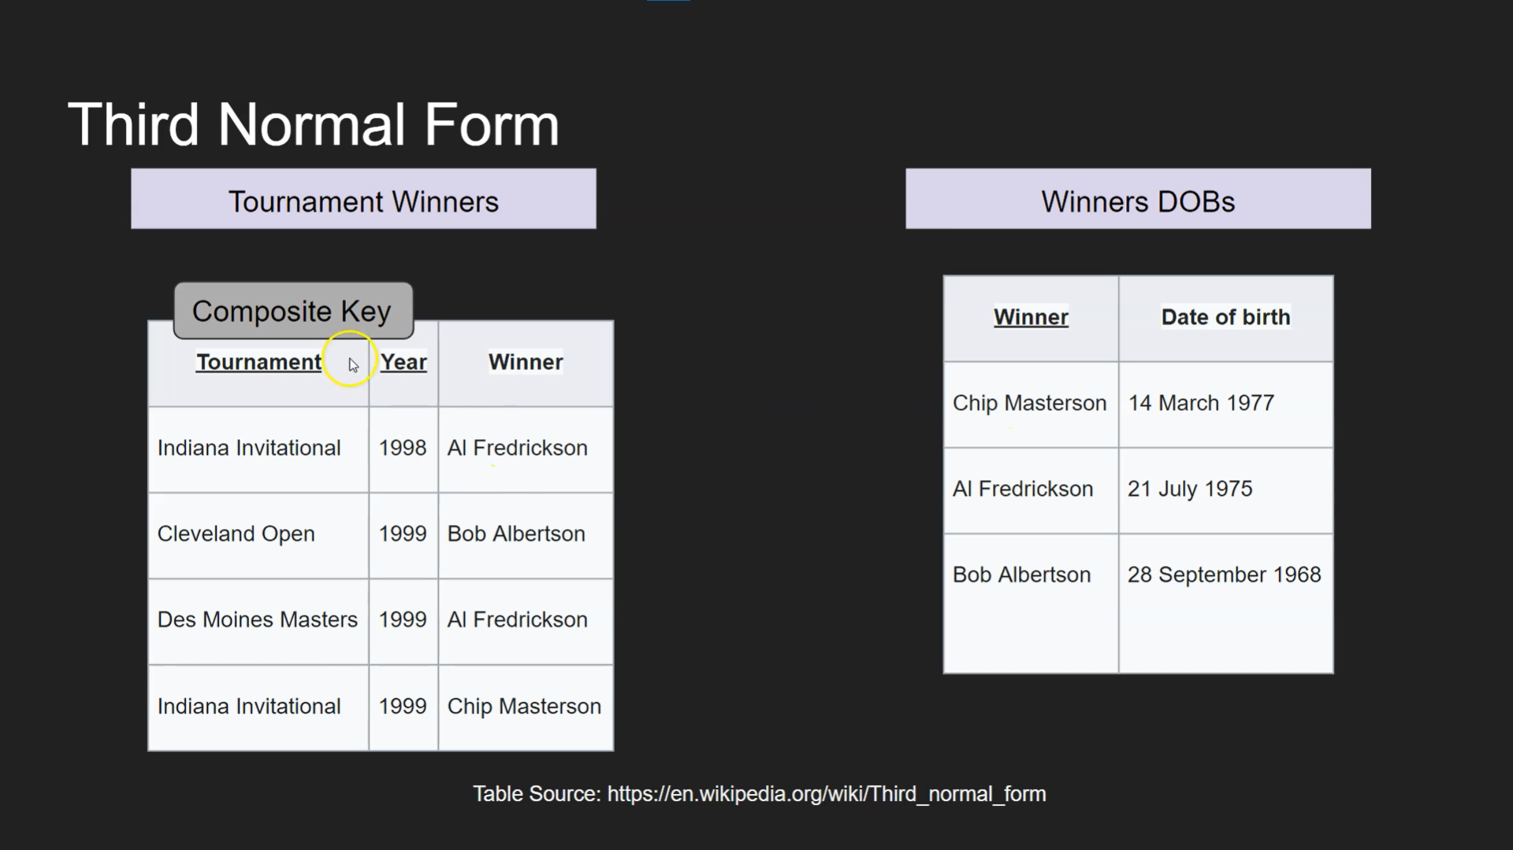

ACID
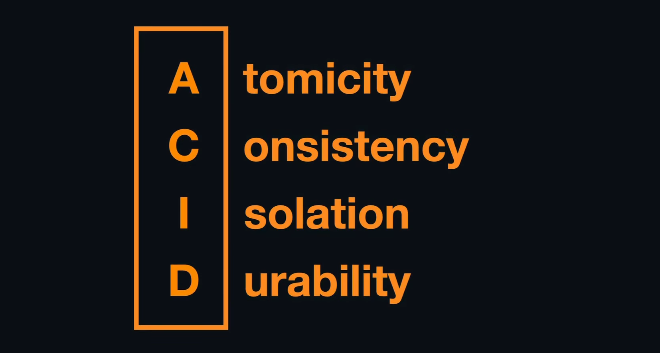

Youtube: ACID Explained: Atomic, Consistent, Isolated & Durable

Atomicity
Atomicity ensures that a transaction is treated as a single unit, which either completes in full or doesn't happen at all. For example, consider transferring $100 from Account A (which has $1000) to Account B (which has $200). The transaction involves several steps:
- Check Balance: Verify that Account A has enough money for the transfer.
- Deduct Amount: Subtract $100 from Account A, reducing its balance to $900.
- Add Amount: Add $100 to Account B, increasing its balance to $300.
In an atomic transaction, if any of these steps fail, all previous steps are rolled back, and the system returns to its original state:
- If the check fails (e.g., Account A doesn't have enough money), no changes are made.
- If the deduction fails (e.g., a system error occurs while deducting from Account A), the addition to Account B is not done, and Account A's balance remains unchanged.
The transaction must be atomic to ensure that either all steps succeed or none of them do, maintaining consistency in the financial records.

Consistency
Consistency: This principle ensures that a database remains in a valid state before and after a transaction. Consistency guarantees that any transaction will bring the database from one valid state to another, maintaining all predefined rules, constraints, and relationships. For example, if there are constraints such as NOT NULL or POSITIVE, these rules must be followed. If a transaction would violate these constraints, it is rolled back, ensuring that the database adheres to its defined rules and remains consistent.

Isolation
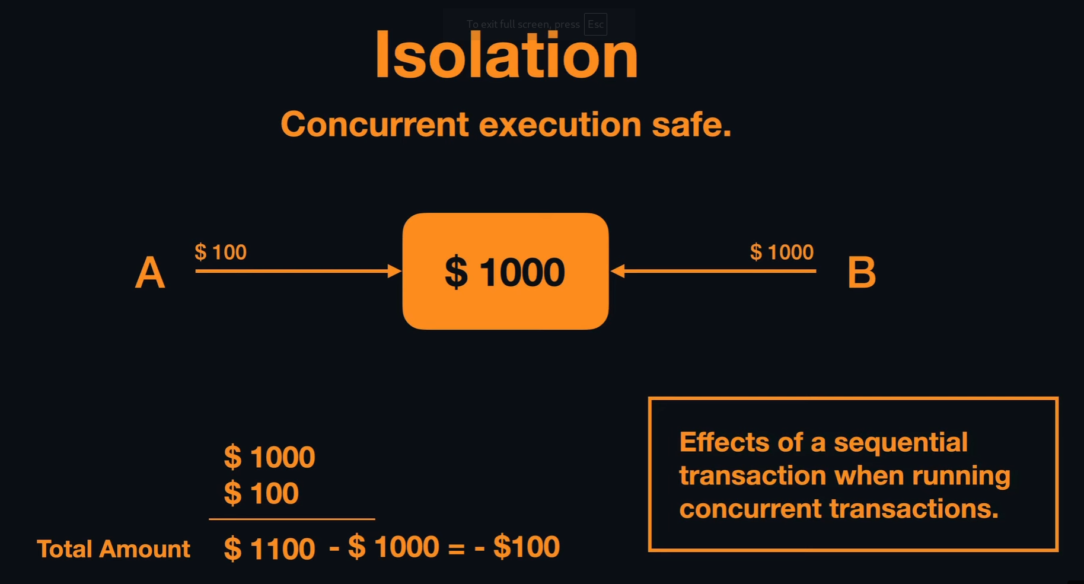
Isolation: This principle ensures that transactions are executed independently and transparently. When multiple transactions are occurring concurrently, isolation guarantees that each transaction is isolated from others, preventing them from interfering with each other. For example, if one transaction is withdrawing $800 from an account with $1000, and another transaction simultaneously tries to withdraw $300, isolation ensures that these transactions do not overlap or interfere. Each transaction sees a consistent state of the database, as if it is the only transaction being processed. This prevents issues such as the account balance going negative due to concurrent access.

This explanation clarifies that isolation ensures each transaction operates independently to avoid conflicts and maintain data integrity.

Durability
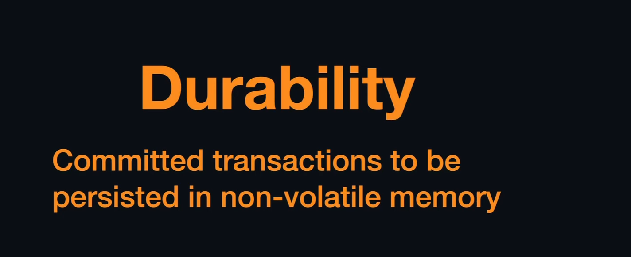

Durability: This principle ensures that once a transaction has been committed, its changes are permanent and will not be lost, even in the case of a system failure or crash. Once a transaction is completed and confirmed, its results are saved to the database and persist through any subsequent failures or restarts. This means that even if there is a power outage or a crash, the changes made by the committed transaction will be preserved, ensuring the database's integrity and consistency.

The data will be saved to non volatile memory rather than main memory after completing an operation.

Queries
- psql -U postgres
- CREATE DATABASE name;
- \l -For checking available databases.
- \c name
- CREATE TABLE employees(
id SERIAL PRIMARY KEY,
name VARCHAR(50) NOT NULL,
salary INT);
- \dt to see all tables
- \d - To see all the tables in the database
- \d employees - To see all the table headings
- INSERT INTO employees ( name, salary)
values(’John’, 50000);
- DROP TABLE employees;
- SELECT * FROM employees;
- SELECT * FROM employees LIMIT 5 - This shows only first 5 rows
- SELECT * FROM employees OFFSET 5 LIMIT 3; -Shows 3 rows after first 5 rows
- SELECT salary FROM employees;
- SELECT name, salary FROM employees;

- SELECT * FROM employees ORDER BY name DESC;
- SELECT DISTINCT name FROM employees;
- SELECT * FROM employees
WHERE gender = ‘female;
- SELECT * FROM customers WHERE country = 'usa' AND country = ‘Canada’;
- SELECT * FROM customers WHERE country IN (‘usa’, ‘Canada’);
- SELECT * FROM employees WHERE dob < 2000-01-01;
- SELECT * FROM employees WHERE dob BETWEEN DATE ‘1990-01-01’ AND ‘2000-01-01’;
- SELECT * FROM employees WHERE name LIKE ‘A%’;
- SELECT * FROM employees WHERE email LIKE ‘%.com’;
- SELECT * FROM employees WHERE name ILIKE ‘A%’;
- SELECT * FROM employees WHERE email LIKE ‘%google%’;
- SELECT * FROM customers
WHERE city LIKE '___don%';
- ALTER TABLE employees - Add a new column
ADD COLUMN age INT;
- ALTER TABLE employees
ADD COLUMN age INT DEFAULT 0; Adds default value to existing column
- UPDATE employees
SET age = 45
WHERE Id = 123;
- UPDATE person SET first_name = ‘Arun’, last_name = ‘B’, age = 33 WHERE id = 100;
- SELECT place, COUNT(*) FROM employees GROUP BY place;- Find number of occurrence of place and shows count
- SELECT place, COUNT(*) FROM employees GROUP BY place HAVING COUNT(*) > 5 ORDER BY COUNT;

- SELECT max(salary) FROM employees;
- SELECT AVG(column_name) FROM your_table;
- SELECT ROUND(AVG(price) FROM car;
- SELECT SUM(order_number) FROM customers;
- SELECT make, MIN(price) FROM car GROUP BY make;
- SELECT make, AVG(price) FROM car GROUP BY make;
- SELECT * FROM customers WHERE country IN ('USA', 'Canada');
- SELECT * FROM customers WHERE country NOT IN ('USA', 'Canada');
- SELECT customer_name AS people
FROM customers;
- SELECT customer_name || country AS product
FROM products;

- ALTER TABLE staff DROP COLUMN join_date; Drop the column
- ALTER TABLE staff ALTER COLUMN age type VARCHAR(5);
- ALTER TABLE staff RENAME TO staff_new; Rename the table
- ALTER TABLE staff RENAME COLUMN first_name TO full_name; Rename a column.
- ALTER TABLE staff_new ADD CONSTRAINT uniq_stf UNIQUE (staff_type); Add constraint to existing table. Uniq_stf is just a name for a unique data type.
- Delete all records where the column brand has the value 'Volvo'.
DELETE FROM cars WHERE brand = ‘volvo’;
- SELECT staff_id, salary,
CASE
WHEN salary >= 10000 THEN 'High Salary'
WHEN salary BETWEEN 5000 AND 10000 THEN 'Average Salary'
WHEN salary < 5000 THEN 'Too Low'
END AS RANGE
FROM staff_salary

- SELECT * FROM person
JOIN car ON person.car_id = car.id Inner Join

- SELECT testproduct_id, product_name, category_name
FROM testproducts
CROSS JOIN categories;
- SELECT customers.customer_name, COUNT(orders.order_id)
FROM orders
LEFT JOIN customers ON orders.customer_id = customers.customer_id
GROUP BY customer_name;
- SELECT * FROM staff
UNION
SELECT * FROM student;
- SELECT COUNT(customer_id), country
FROM customers
GROUP BY country;
- SELECT country, count(*) FROM customers GROUP BY country HAVING count(*) > 4;
- SELECT e.emp_name, d.dept_name, m.manager_name FROM
employee e LEFT JOIN department d
ON e.dept_id = d.dept_id
INNER JOIN manager m ON m.manager_id = e.manager_id

- Update a columns items by filtering:-

UPDATE table_name
SET model = 'Alto'
WHERE brand = 'Suzuki';

- Change data type of a column

ALTER TABLE table_name
ALTER COLUMN year TYPE VARCHAR(4);

- Delete all records from the table cars.
DELETE FROM cars;

- Delete all records from the table cars. Another method
TRUNCATE TABLE cars;

Others
Find min with details

SELECT * FROM car WHERE price = (SELECT MAX(price) from car);

SELECT * FROM car ORDER BY price DESC LIMIT 1;

Find offer price

SELECT id, make, model, price, ROUND(price - (price * 0.10)) from car;

Coalesce

SELECT first_name, COALESCE(email, 'XXXXXX') FROM person;

Add a unique constraint to a table

ALTER TABLE person

ADD CONSTRAINT unique_email UNIQUE(email);

Check

ALTER TABLE person

ADD CONSTRAINT gender_constraint CHECK (gender = 'Female' OR gender = 'Male');

This is query is used to check the column has only ‘Male’ or ‘Female’

Foreign Key

CREATE TABLE car (

id BIGSERIAL NOT NULL PRIMARY KEY, -- Auto-incrementing primary key

make VARCHAR(100) NOT NULL, -- Car make (required)

model VARCHAR(100) NOT NULL, -- Car model (required)

price NUMERIC(19, 2) NOT NULL -- Price with two decimal places (required)

);

CREATE TABLE person (

id BIGSERIAL NOT NULL PRIMARY KEY, -- Auto-incrementing primary key

first_name VARCHAR(50) NOT NULL, -- First name (required)

last_name VARCHAR(50) NOT NULL, -- Last name (required)

gender VARCHAR(7) NOT NULL, -- Gender (required)

email VARCHAR(100), -- Email (optional)

date_of_birth DATE NOT NULL, -- Date of birth (required)

country_of_birth VARCHAR(50) NOT NULL, -- Country of birth (required)

car_id BIGINT REFERENCES car(id) ON DELETE SET NULL -- Foreign key to 'car', allows null

);

Join tables and show column with greater than a value

SELECT person.*, car.*,

CASE

WHEN price > 8000 THEN 'High'

END AS Category

FROM person

LEFT JOIN car ON person.car_id = car.id WHERE price > 70000;

SELECT person.*, car.*,

CASE

WHEN car.price > 8000 THEN 'High'

ELSE 'LOW'

END AS Category

FROM person

LEFT JOIN car ON person.car_id = car.id;

Outer Join

SELECT owner_name, car_model

FROM owners

FULL OUTER JOIN cars

ON owners.car_id = cars.car_id;

Some Random Theory Notes
What is postgres:
PostgreSQL is an free open-source database system that supports both relational (SQL) and non-relational (JSON) queries. PostgreSQL is a back-end database for dynamic websites and web applications.
PostgreSQL supports the most important programming languages:
- Python
- Java
- C/C++
- C#
- Node.js
- Go

Commands for Postgres
Enter the password
For creating new database – CREATE DATABASE DATABASE NAME, then enter ;
To check other existing data bases - \l
To enter into a particular database - \c databasename ex: \c student;
To exit a database: \q

Entire the requirement, if class: create table class
To see the data in table: select * from tablename;
To enter data into table: insert into tablename (column names(1), column names(2)) values (‘value1’ , ’value2’);
Ex: insert into class1 (name,address) values ('Neenu','Thodupuzha');
To enter values from second row: we can add based on row number
Ex: insert into class1 values ('2','Roffy','Vannappuram');
To arrange the table in ascending order: select * from tablename order by columnname;
Ex: select * from class1 order by name;
To arrange table data in descending order: select * from tablename order by columnname desc;
Ex: select * from class1 order by name desc;

Notes:
DBMS – Data Base Management System
A database is a structured collection of data, organized and stored in a way that allows for efficient retrieval, management, and manipulation of information. It is used to store and manage data, making it easier to access, update, and analyze information.
Key characteristics of a database include:
1. Structured Data: Databases store data in a structured format, typically using tables or other data structures. Each table consists of rows and columns, where each row represents a record, and each column represents a specific attribute or field of the data.
2. Data Integrity: Databases often enforce rules and constraints to maintain data integrity. This ensures that data is accurate and consistent, preventing the entry of invalid or inconsistent information.
3. Query Language: Databases come with a query language (e.g., SQL - Structured Query Language) that allows users to retrieve, update, and manipulate data. Users can perform complex searches and operations on the data using these languages.
4. ACID Properties: Databases are designed to adhere to the ACID properties, which stand for Atomicity, Consistency, Isolation, and Durability. These properties ensure that database transactions are reliable and maintain data integrity, even in the face of system failures.
5. Concurrent Access: Databases allow multiple users or applications to access and manipulate data concurrently, while managing potential conflicts through locking mechanisms and isolation levels.
6. Scalability: Databases can be designed to scale horizontally (adding more servers) or vertically (increasing the resources of a single server) to handle increasing amounts of data and user requests.
7. Indexing: To improve query performance, databases often use indexing, which is a data structure that provides quick access to specific rows in a table based on the values in one or more columns.
There are different types of databases, including:
- Relational Databases: These databases use tables to store data and employ structured query languages like SQL for data manipulation. Examples include MySQL, PostgreSQL, and Oracle Database.
- NoSQL Databases: These databases are designed to handle unstructured or semi-structured data and may not use traditional tables. They are suitable for use cases like big data, real-time applications, and document storage. Examples include MongoDB, Cassandra, and Redis.
- NewSQL Databases: These databases combine the scalability of NoSQL with the ACID compliance of traditional relational databases. They aim to provide the best of both worlds.
- Graph Databases: These databases are optimized for storing and querying graph-like data structures, making them ideal for applications involving complex relationships. Examples include Neo4j and Amazon Neptune.

Databases are a fundamental component of modern software systems, powering everything from simple web applications to complex enterprise systems, data analytics, and more. They play a crucial role in organizing and managing data, making it accessible and useful to users and applications.
There 2 types of databases
- Relational -SQL
- Non-relational – NoSQL
SQL – Structured Query Language
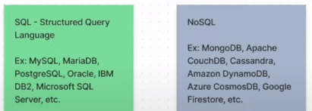
RDBMS – Relational Data Base Management System
DBA – Data Base Administrator
3 main processes in SQL
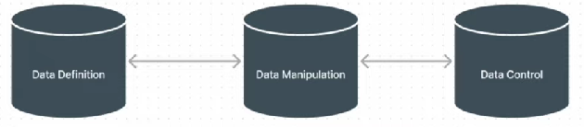
A Database Management System (DBMS) is software that facilitates the creation, organization, manipulation, and management of databases. It provides an interface for users and applications to interact with the database by performing various operations such as data entry, retrieval, updating, and deletion. The DBMS acts as an intermediary between the users and the physical database, ensuring data integrity, security, and efficient data handling.
Key features and functions of a DBMS include:
1. Data Definition: DBMS allows users to define the structure of the database, including the creation of tables, specifying data types, defining relationships between tables, and setting constraints on data to ensure accuracy and consistency.
2. Data Manipulation: Users can insert, retrieve, update, and delete data from the database using query languages like SQL. DBMS optimizes these operations for performance and data integrity.
3. Data Security: DBMS provides mechanisms to control access to the database, defining user roles and permissions to restrict unauthorized access and protect sensitive data.
4. Data Integrity: DBMS enforces data integrity constraints, such as primary keys, foreign keys, and unique constraints, to maintain the quality and consistency of data.
5. Concurrent Access: DBMS manages concurrent access to the database by multiple users or applications, ensuring that transactions do not interfere with each other and that data remains consistent.
6. Backup and Recovery: It offers tools and procedures for creating backups of the database and restoring it to a consistent state in case of system failures or data corruption.
7. Query Optimization: DBMS optimizes query execution to provide efficient and speedy retrieval of data by creating execution plans, using indexing, and caching frequently accessed data.
8. Transaction Management: DBMS ensures the reliability of database transactions by adhering to ACID (Atomicity, Consistency, Isolation, Durability) properties. Transactions are treated as all-or-nothing operations.
9. Concurrency Control: DBMS manages concurrent access to the database, preventing conflicts and ensuring data consistency through mechanisms like locking and isolation levels.
10. Data Modeling: DBMS often includes tools for designing and modeling the database schema, helping users create a logical representation of their data.
Common types of DBMS include:

1. Relational DBMS (RDBMS): These DBMS systems store data in tables with rows and columns, and they use SQL for data manipulation. Examples include MySQL, PostgreSQL, Microsoft SQL Server, and Oracle Database.
2. NoSQL DBMS: These databases are designed to handle unstructured or semi-structured data and are often used for big data and real-time applications. Examples include MongoDB, Cassandra, and Redis.
3. NewSQL DBMS: These systems combine the scalability of NoSQL databases with ACID compliance similar to traditional RDBMS, aiming to provide a balance between the two.
4. Object-Oriented DBMS (OODBMS): These databases are designed to store complex, interconnected objects, making them suitable for applications with complex data structures. Examples include db4o and Versant.
The choice of DBMS depends on the specific requirements of the application, the type of data being stored, and performance considerations. Different DBMS systems excel in different use cases, and the selection should be made based on the project's needs and constraints.
A Relational Database Management System (RDBMS) is a type of Database Management System (DBMS) that organizes and manages data using a relational model. In this model, data is organized into tables (also known as relations) composed of rows and columns. RDBMS systems are based on a set of principles known as the relational model, which was developed by Edgar F. Codd in the early 1970s. The relational model defines how data should be structured and manipulated, providing a foundation for efficient data storage and retrieval.
Key features and concepts of RDBMS include:
1. Tables: Data is organized into tables, where each table represents a specific entity or concept. Each row in a table represents a unique record or data point, while each column represents an attribute or field of that record.
2. Schema: The structure of the database, including the tables, columns, data types, constraints, and relationships, is defined using a schema. The schema serves as a blueprint for the database.
3. Primary Keys: Each table typically has one or more columns designated as primary keys. A primary key is a unique identifier for each record in the table, ensuring that each row is distinct.
4. Foreign Keys: Foreign keys are used to establish relationships between tables. They link a column in one table to the primary key of another table, creating referential integrity and allowing for data consistency and integrity.
5. SQL (Structured Query Language): RDBMS systems use SQL to perform operations on the data, including querying, inserting, updating, and deleting records. SQL provides a standardized language for interacting with relational databases.
6. ACID Properties: RDBMS systems adhere to the ACID properties (Atomicity, Consistency, Isolation, Durability) to ensure that database transactions are reliable, maintain data integrity, and recover from failures.
7. Data Integrity Constraints: RDBMS allows the definition of various data integrity constraints, such as unique constraints, check constraints, and default values, to maintain data quality.
8. Normalization: Normalization in a database is a process used to organize and structure data in a way that reduces data redundancy and ensures data integrity. The main goal of normalization is to eliminate data anomalies that can arise when data is stored in a non-standardized or denormalized format. It helps maintain data consistency and makes it easier to update, insert, and delete records in a database without introducing errors. Normalization is typically carried out by breaking down a large table into smaller, related tables and establishing relationships between them.
9. Indexing: Indexes are used to speed up data retrieval by providing quick access to specific rows based on the values in one or more columns. Indexes enhance query performance.
Examples of popular RDBMS systems include:

1. MySQL
2. PostgreSQL
3. Microsoft SQL Server
4. Oracle Database
5. IBM Db2
6. SQLite

RDBMS systems are widely used in various industries and applications, including web development, enterprise software, financial systems, and more, due to their robustness, data consistency, and support for complex querying and reporting. They are particularly suitable for scenarios where structured and tabular data needs to be stored and managed efficiently.
PostgreSQL, often referred to as "Postgres," is a powerful and open-source relational database management system (RDBMS). It is known for its robustness, extensibility, and adherence to SQL standards. PostgreSQL is used in a wide range of applications, from small-scale projects to large-scale enterprise systems, and it is particularly popular among developers and organizations for its advanced features and scalability.
Here are some key features and characteristics of PostgreSQL:
1. **Open Source**: PostgreSQL is open-source software, which means it is freely available for anyone to use, modify, and distribute. This open-source nature has contributed to its widespread adoption and community-driven development.
2. **ACID Compliance**: PostgreSQL adheres to the ACID properties (Atomicity, Consistency, Isolation, Durability), ensuring data consistency and reliability even in the face of system failures.
3. **Extensibility**: PostgreSQL supports extensions and custom functions, allowing developers to add new features and data types. This extensibility makes it highly adaptable to various use cases.
4. **Data Types**: PostgreSQL offers a wide range of built-in data types, including standard SQL types, custom types, and user-defined types. It also supports arrays, hstore (a key-value store), and JSON data types.
5. **Advanced Indexing**: PostgreSQL provides various indexing methods, including B-tree, Hash, GiST, GIN, and SP-GiST, to optimize query performance.
6. **Full-Text Search**: It includes a powerful full-text search engine with support for advanced search features and indexing capabilities.
7. **Concurrency Control**: PostgreSQL handles concurrent access effectively through multi-version concurrency control (MVCC), allowing multiple transactions to occur simultaneously without conflicts.
8. **Geospatial Data**: PostgreSQL has robust support for geospatial data and offers a range of functions and operators for working with spatial data.
9. **JSON Support**: In addition to JSON data types, PostgreSQL includes a rich set of functions for working with JSON data, making it suitable for applications that require NoSQL-like flexibility.
10. **Replication**: PostgreSQL supports various replication options, including streaming replication and logical replication, to create high-availability and fault-tolerant setups.
11. **Partitioning**: It offers table partitioning to optimize the management of large datasets by dividing them into smaller, manageable chunks.
12. **Security**: PostgreSQL provides robust security features, including role-based access control, SSL certificate authentication, and encryption.
13. **Community and Ecosystem**: PostgreSQL has a vibrant and active community of users and developers who contribute to its development and provide support through mailing lists, forums, and conferences.
14. **Cross-Platform**: PostgreSQL is available for multiple operating systems, including Linux, Windows, macOS, and more.
PostgreSQL's versatility and rich feature set make it a popular choice for a wide range of applications, from small-scale projects to large, mission-critical systems. It is often favored by organizations and developers who require a highly customizable and open-source relational database solution.
DATABASE USED IN PYTHON:
Python provides several libraries and tools for working with databases. These libraries allow you to interact with databases, execute SQL queries, and retrieve or manipulate data. Some of the popular databases used in Python include:
1. **SQLite**: SQLite is a lightweight, embedded relational database that comes bundled with Python. It is suitable for small to medium-sized applications and is often used for prototyping and development. You can work with SQLite databases using the built-in `sqlite3` module in Python.
2. **MySQL**: MySQL is a popular open-source relational database management system. You can interact with MySQL databases in Python using libraries such as `mysql-connector-python`, `PyMySQL`, or third-party ORMs like SQLAlchemy.
3. **PostgreSQL**: PostgreSQL is a powerful open-source relational database system. You can work with PostgreSQL databases in Python using libraries such as `psycopg2` or SQLAlchemy.
4. **MongoDB**: MongoDB is a popular NoSQL database. You can interact with MongoDB in Python using the `pymongo` library.
These are just a few examples of databases commonly used in Python. Depending on your project's requirements, you can choose the appropriate database and library to work with relational or NoSQL databases seamlessly within your Python applications.

Datatypes in PostgreSQL:
PostgreSQL is a powerful open-source relational database management system that supports various data types. These data types can be categorized into several groups based on their characteristics and use cases. Here are some of the main data types in PostgreSQL:
1. Numeric Types:
- `integer` (int): Stores whole numbers.
- `bigint`: Stores large whole numbers.
- `decimal` or `numeric`: Stores arbitrary precision numbers.
- `real` or `float4`: Stores single-precision floating-point numbers.
- `double precision` or `float8`: Stores double-precision floating-point numbers.
2. Character Types:
- `character varying(n)` or `varchar(n)`: Stores variable-length character strings with a maximum length of `n` characters.
- `character(n)` or `char(n)`: Stores fixed-length character strings with a length of `n` characters.
- `text`: Stores variable-length character strings with no specified length limit.
3. Binary Data Types:
- `bytea`: Stores binary data as variable-length binary strings.
4. Date and Time Types:
- `date`: Stores dates (year, month, day).
- `time`: Stores times of the day.
- `timestamp`: Stores date and time.
- `interval`: Stores time intervals.
- `timestamptz`: Stores timestamp with time zone information.
5. Boolean Type:
- `boolean`: Stores true or false values.
6. Enumerated Types:
- `enum`: Defines a list of values that a column can take.
7. Geometric Types:
- Various types like `point`, `line`, `lseg`, `box`, `path`, `polygon`, `circle` for storing geometric data.
8. Network Address Types:
- `inet`: Stores IPv4 and IPv6 addresses.
- `cidr`: Stores IPv4 and IPv6 networks.
- `macaddr`: Stores MAC addresses.
9. Bit Strings:
- `bit(n)`: Stores fixed-length bit strings.
- `bit varying(n)`: Stores variable-length bit strings.
10. UUID Type:
- `uuid`: Stores universally unique identifiers.
11. Text Search Types:
- `tsvector`: Stores text search vector data.
- `tsquery`: Stores text search query data.
12. JSON Types:
- `json`: Stores JSON data.
- `jsonb`: Stores binary JSON data, which is more efficient for querying.
13. Array Types:
- `array`: Stores arrays of any data type.
14. Composite Types:
- `composite`: Allows you to create custom data types composed of multiple fields.
15. Domain Types:
- `domain`: A user-defined data type that is based on an existing data type, allowing for constraints and validation.
16. Range Types:
- `range`: Stores a range of values of a specified data type.
17. UUID Types:
- `pg_lsn`: Log sequence number, used for replication and logical decoding.
These are some of the core data types in PostgreSQL. PostgreSQL is highly extensible, and you can create custom data types as needed to suit your application's requirements. Additionally, PostgreSQL also supports array and hstore (key-value) data types for more complex data storage needs.
What are constraints in database?
In a database, constraints are rules or conditions that are defined to enforce data integrity, accuracy, and consistency. Constraints ensure that data in a database meets certain criteria or adheres to specific rules, preventing invalid or inconsistent data from being stored. They help maintain the quality and reliability of the data within the database.
Bigserial data type:
In PostgreSQL, bigserial is a data type used for creating an auto-incrementing integer column that can hold large integer values. It is typically used for defining primary key columns that automatically generate unique values for each inserted row. Here's how bigserial is used and its purpose:

Auto-Incrementing Primary Key: bigserial is commonly used to create auto-incrementing primary key columns in database tables. When you define a column as bigserial, PostgreSQL automatically generates a unique sequential integer value for each new row inserted into the table.
When using big serial in a table creation, a sequence also will be created along with table.

YouTube Channel followed: https://www.youtube.com/watch?v=yLqvIitbJR4&list=PLDkmTW84K1nuHnbviOtwf32sDmrom1zSi&ab_channel=MFCCreations

In CMD to enter as postgre user: psql -U postgre
To see the list of all existing databases
To create a new data base
Here NL is the name of the database
To enter into any existing database
Create a table after entering the database
here itemlist is the table name, also inside bracket we need to mention the list of columns needed. Along with column name we need to mention the data type of each column.
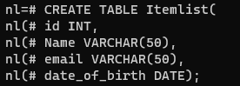
To see the details of tables in a database:
To see the details of a table with datatype details:
To delete a table,
If we need to keep an id as unique, (here employee is the table name)
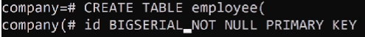
If we want to get a particular column as unique, then we can use the constrain(condition) -PRIMARY KEY, BIGSERIAL is a data type for auto-increamenting.

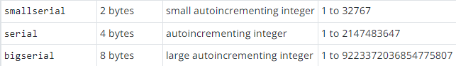
UNIQUE is also a constrain – which is used when there is no duplicate allowed for that column value.
Whenever we are using Big serial data type, after creation of table it will generate an employee_id_sequence.
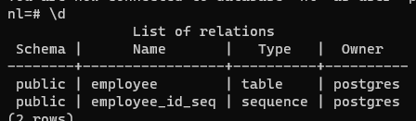

How to insert data in an already created table.
To insert data use , INSERT INTO table_name (column names)
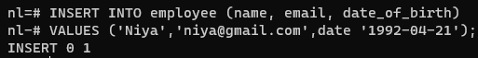
Adding multiple row values at once: ex.
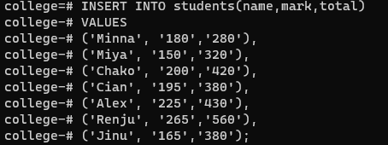
After entering the data to see the content of the table, use
If we want to see only particular columns, then instead of * use the required column name.
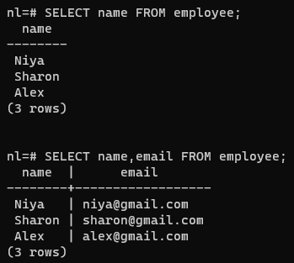
To sort the table content based on some column value in ascending or descending order use:
Here it is sorted based on name column.
We can sort based on more than one column.
If we have duplicate records in a column, then to show the unique values in the column, use
Here date_of_birth is the column we are trying to display
To add a new column to an existing column:
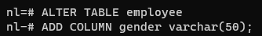
To add a default value to the newly added column
To delete only one column:
To filter a column content using ‘WHERE’
Use of AND keyword:
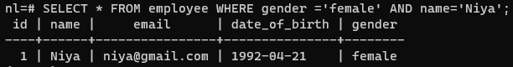
OR
< > operators also can be used:

To update only one column record for a single row;
To see the table for a particular id limit:
To start the selection from a particular range: OFFSET
We can use without Limit also, then it will be showing from offset number till end of list.
Another way to select a specific range of data: FETCH
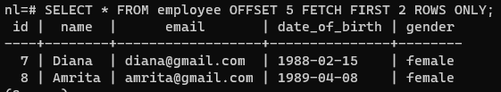
OR operation:
Use of IN:
Use of BETWEEN:
Use of LIKE:
% in the starting means last letter of value of the name column. Ex: ‘%a’
% after letter means first letter of value of the name column. Ex: ‘L%’
LIKE - is case sensitive
iLike - is not case sensitive.
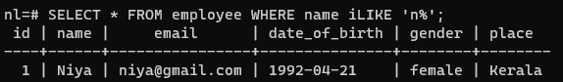

GROUP BY:
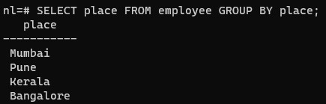
Including COUNT:
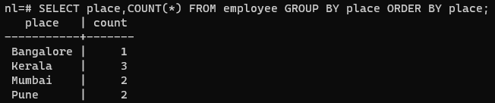

HAVING:
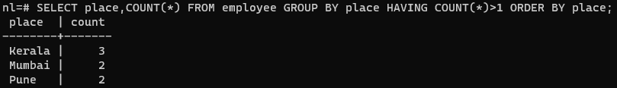
To change the data type of an already entered column
Aggregate Functions:
Max:
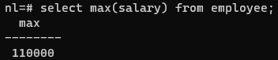
Min:
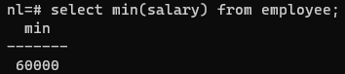
Avg:
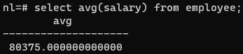
Round: To round of the value
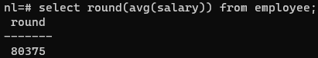
Sum:
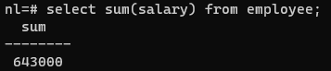
Arithmetic Operations:
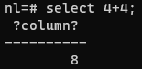
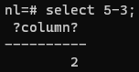
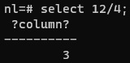
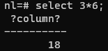
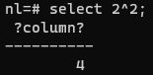

We can do arithmetic operations in a table directly: here we are finding the mark %
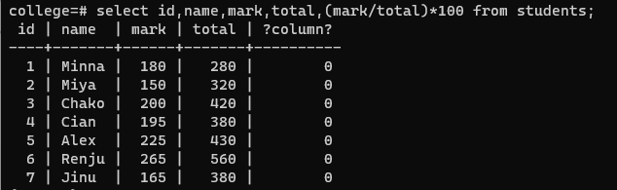
COALESCE:
If a table column is not having values in all the rows, then for the null values we can use a default value using COALESCE keyword.
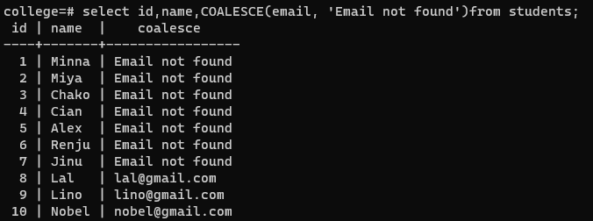
Timestamps and Dates:
To find the current time:
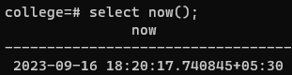
To get only date:
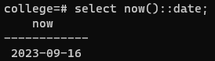
To get only time:
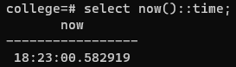
EXTRACT keyword
To get only year:
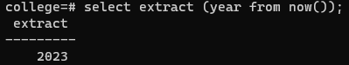
To get only month:
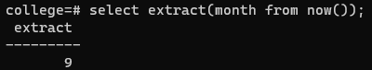
To get only day:
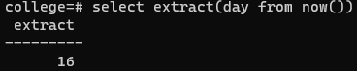
To get only century:
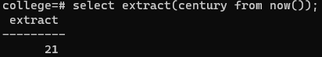
INTERVAL
To find future and past dates:
Future:
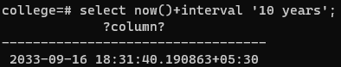
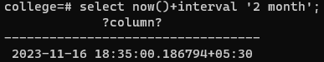
Past:
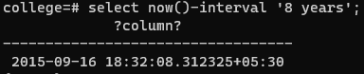
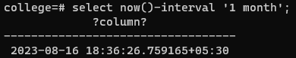
To get only date:
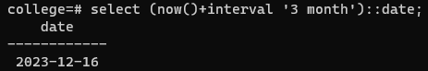
CONSTRAINS:
- NOT NULL – value is mandatory
- UNIQUE – to avoid value duplication
- PRIMARY KEY – to identify each record in the data table uniquely
- FOREIGN KEY – to relate to tables, foreign key in one table will be the primary key from other table.
- CHECK – to allow a particular value/s in a colum
- DEFAULT – to apply default values in a table column
APPLY CONSTRAINTS DURING TABLE CREATION:
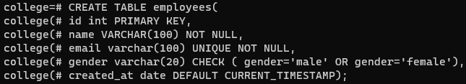
APPLY CONSTRAINTS AFTER TABLE CREATION:
First table created without adding any constraints. After table creation adding constraints.
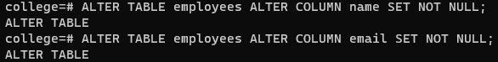

TABLE UPDATION:
Table record deletion:
If specific record with WHERE is not mentioned, it will delete all the records from table.
HANDLE Conflicts:
UPSERT – UPDATE + INSERT
If conflict – update
No conflict -insert

Theory:
ACID properties:
A database transaction is a single unit of work that consists of one or more operations.
A PostgreSQL transaction is atomic, consistent, isolated, and durable. These properties are often referred to as ACID:
- Atomicity guarantees that the transaction completes in an all-or-nothing manner.
- Consistency ensures the change to data written to the database must be valid and follow predefined rules.
- Isolation determines how transaction integrity is visible to other transactions.
- Durability makes sure that transactions that have been committed will be stored in the database permanently.
Normalization:
Normalization in PostgreSQL (often abbreviated as "psql") refers to the process of organizing and structuring a relational database to reduce data redundancy and improve data integrity. The goal of normalization is to ensure that data is stored efficiently without unnecessary duplication while maintaining data consistency. It is essential for maintaining data quality and preventing anomalies like update anomalies, insert anomalies, and delete anomalies.
Normalization is typically achieved by dividing a database into multiple related tables and establishing relationships between them using foreign keys. There are different normal forms, with each successive normal form (from 1NF to 5NF) having stricter rules for organizing data.
Here are the first three normal forms (1NF, 2NF, and 3NF) and how they relate to PostgreSQL:
1. **First Normal Form (1NF):** In 1NF, each column in a table must hold atomic (indivisible) values. There should be no repeating groups or arrays in a column.
For example, consider a table for storing customer orders. Instead of having a single "Products" column with a list of products, you would create a separate table for products and establish a relationship between the orders and products using foreign keys.
2. **Second Normal Form (2NF):** In 2NF, a table must meet the requirements of 1NF, and all non-key attributes (columns) must be fully functionally dependent on the entire primary key.
In PostgreSQL, you achieve this by breaking tables down into smaller tables that represent specific entities and their attributes. This ensures that each table has a clear primary key and attributes that are dependent on that key.
3. **Third Normal Form (3NF):** In 3NF, a table must meet the requirements of 2NF, and there should be no transitive dependencies. Transitive dependencies occur when non-key attributes depend on other non-key attributes.
To achieve 3NF, you might further break down tables and separate attributes that depend on other non-key attributes into their own tables. Here's an example in PostgreSQL syntax:
In this example, data is normalized into multiple tables (customers, products, orders, and order_details), and foreign keys establish relationships between them. This structure follows the principles of normalization to reduce data redundancy and maintain data integrity.
Constraints in postgresql:
In PostgreSQL, constraints are rules that you can define to ensure data integrity and enforce specific conditions on the data stored in your database tables. Constraints help maintain the accuracy and consistency of the data in your database. Here are some common types of constraints in PostgreSQL:
Primary Key, Unique, Check, Foreign Key, Not Null, Exclusion
Relationships: refer chat GPT also
https://hasura.io/learn/database/postgresql/core-concepts/6-postgresql-relationships/
There are 3 types of table relationships in a relational database. The relationships can be enforced by defining the right foreign key constraints on the columns.

One-to-One and One-to-Many

A one-to-one relationship between two tables can be established via a unique foreign key constraint.
Say we have the following two tables in our database schema:
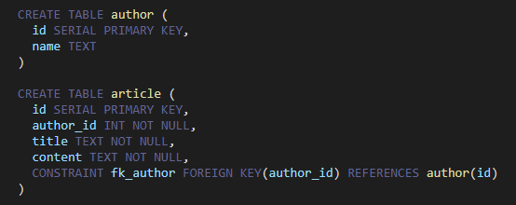
These two tables are related via
one-to-one relationship. An article can have one author.
one-to-many relationship. An author can have multiple articles.

Many-to-Many
A many to many relationship is typically created using a join table.
Consider the following two tables article and tag.
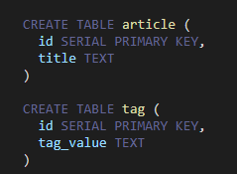
In practical use cases, each article can have multiple tags and each tag can be mapped to multiple articles.
Now let us create a bridge table called article_tag.
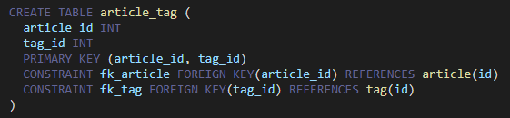
We have applied two foreign key constraints, one for article_id and one for tag_id. The table article_tag is the bridge table involved in the many-to-many relationship.

JOINTS in PSQL:
In PostgreSQL (often abbreviated as "psql"), joins are used to combine rows from two or more tables based on a related column between them. Joins allow you to retrieve data from multiple tables in a single query, creating a more comprehensive and meaningful result set. PostgreSQL supports various types of joins, including INNER JOIN, LEFT JOIN (or LEFT OUTER JOIN), RIGHT JOIN (or RIGHT OUTER JOIN), and FULL JOIN (or FULL OUTER JOIN). Here's how you can use these joins in PostgreSQL:

1. INNER JOIN:
- The INNER JOIN returns only the rows that have matching values in both tables.
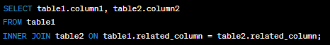
2. LEFT JOIN (or LEFT OUTER JOIN):
- The LEFT JOIN returns all rows from the left table (table1), and the matched rows from the right table (table2). If there's no match, NULL values are returned for columns from the right table.
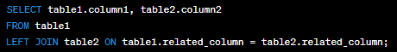
3. RIGHT JOIN (or RIGHT OUTER JOIN):
- The RIGHT JOIN returns all rows from the right table (table2), and the matched rows from the left table (table1). If there's no match, NULL values are returned for columns from the left table.
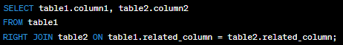
4. FULL JOIN (or FULL OUTER JOIN):
- The FULL JOIN returns all rows when there is a match in either the left or right table. If there's no match, NULL values are returned for columns from the table that doesn't have a match.
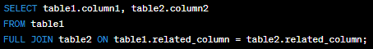
These are the basic join types in PostgreSQL. You can also use aliases to simplify your queries and join more than two tables if needed. Remember to specify the join condition accurately, ensuring that it matches the columns you want to use for the join. Additionally, you can include WHERE clauses and other clauses to further filter and manipulate your query results.

3-Schema architecture PSQL:
The term "3-Schema architecture" in the context of PostgreSQL (PSQL) typically refers to a design approach for structuring a database system to separate different aspects of data management and to improve data integrity and security. This architecture is sometimes also known as the "three-schema architecture" or "three-level architecture." It divides the database system into three main components:

1. External Schema (View Schema):
- This is the top level of architecture.
- It defines how the data is presented to the end users or applications.
- It includes user views, which are logical representations of data tailored to specific user needs.
- Changes in the external schema should not affect the internal schema.

2. Conceptual Schema (Logical Schema):
- This is the middle level of the architecture.
- It represents the logical structure of the entire database, independent of any physical storage considerations.
- It defines the relationships between data elements, entities, and attributes.
- Changes in the conceptual schema should not affect the external schema or require significant modification of the internal schema.

3. Internal Schema (Physical Schema):
- This is the bottom level of the architecture.
- It deals with how data is physically stored on the storage media.
- It includes details such as file organization, indexing methods, and data storage formats.
- Changes in the internal schema should be transparent to both the conceptual and external schemas.

The three-schema architecture provides several advantages:

- **Data Independence**: It separates the logical view (conceptual schema) from the physical view (internal schema), allowing changes in one level to be made without affecting the other levels. This provides data independence and flexibility.

- **Security and Access Control**: Access to data is controlled at the external schema level, making it easier to implement security and access control policies.

- **Simplified Development**: Developers can work with the conceptual schema, which represents the data in a way that makes sense for the application, without needing to be concerned about the physical storage details.

- **Data Integrity**: The separation of concerns and the well-defined structure help ensure data integrity and consistency.

- **Ease of Maintenance**: Changes to the database can be made more easily without impacting the entire system.

In the context of PostgreSQL (PSQL), you can implement a three-schema architecture by defining different database schemas for each of these levels and managing access permissions accordingly. PostgreSQL supports schema management, which allows you to create schemas and organize database objects within them. This separation of schemas can help you implement the three-schema architecture effectively.

Indexing:
In PostgreSQL indexing is a crucial aspect of database performance optimization. Indexes are database objects that improve the speed of data retrieval operations, such as SELECT queries, by providing a quick lookup mechanism. They work by creating a data structure that maps values in one or more columns of a table to their physical locations in the table.
Here's how you can create and work with indexes in PostgreSQL:
**1. Creating Indexes:**
To create an index, you typically use the `CREATE INDEX` statement. Here's the basic syntax:
For example, if you have a table named "employees" and want to create an index on the "last_name" column, you can do:
You can also create indexes on multiple columns by specifying multiple column names in the parentheses:
**2. Types of Indexes:**
PostgreSQL supports various types of indexes, including B-tree (default), Hash, GiST, GIN, SP-GiST, and more. The appropriate type depends on the data and query patterns.
**3. Dropping Indexes:**
To remove an index, use the `DROP INDEX` statement:
For example:

**4. Using Indexes:**
PostgreSQL automatically uses indexes when it determines that doing so would speed up a query. However, you can also provide hints to the query planner using the `EXPLAIN` command:
This will show you the query plan, indicating whether an index is being used and which one.
**5. Maintaining Indexes:**
Indexes need to be maintained as data in the table changes. PostgreSQL does this automatically, but there are cases where you might need to reindex manually, especially if you have a heavily updated table.
To rebuild an index:
**6. Conditional Indexing:**
PostgreSQL allows you to create partial indexes, which only index a subset of rows based on a specified condition. This can be useful for optimizing queries that target specific subsets of data.

CREATE INDEX idx_active_employees ON employees (employee_id) WHERE is_active = true;
This index will only include rows where the "is_active" column is true.

Indexing is a critical aspect of database performance tuning, and the choice of indexes should be based on your specific use case and query patterns. Be cautious not to over-index, as it can lead to increased storage overhead and slower write operations.

Aggregate functions in psql:

In PostgreSQL (often abbreviated as "psql"), aggregate functions are used to perform calculations on sets of values within a column or expression, and return a single value as the result. These functions operate on a group of rows and return a single value for that group. Here are some common aggregate functions in psql:

1. **COUNT**: Counts the number of rows in a result set or a group of rows.

2. **SUM**: Calculates the sum of values in a column.
3. **AVG**: Calculates the average of values in a column.

4. **MIN**: Returns the minimum value in a column.

5. **MAX**: Returns the maximum value in a column.

6. **GROUP BY**: Used to group rows that have the same values in specified columns and apply aggregate functions to each group.
7. **HAVING**: Used with GROUP BY to filter the results of the grouped data based on a condition applied to the result of an aggregate function.

SELECT column1, AVG(column2) FROM table_name GROUP BY column1 HAVING AVG(column2) >10;

8. **ARRAY_AGG**: Aggregates values into an array.

9. **STRING_AGG**: Aggregates string values into a concatenated string.

10. **JSON_AGG**: Aggregates values into a JSON array.

These aggregate functions are very useful for summarizing and analyzing data in PostgreSQL. You can combine them with other clauses like WHERE, ORDER BY, and JOIN to create complex queries that extract meaningful insights from your data.

SCALAR FUNCTIONS:
In PostgreSQL (often abbreviated as "PSQL"), a scalar function cab be build IN or user-defined functions that takes one or more input values and returns a single value as its result. Scalar functions are used to perform calculations, transformations, or operations on data within a single row of a table or on individual values, and they are commonly used in SQL queries to manipulate data.

Here's how you can create and use scalar functions in PostgreSQL:

1. **Function Creation**:
To create a scalar function, you can use the `CREATE FUNCTION` statement. Here's a basic syntax example:
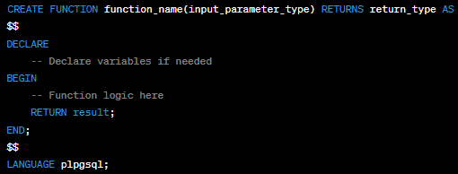
- `function_name`: The name of the function.
- `input_parameter_type`: The data type of the input parameter(s).
- `return_type`: The data type of the result.

2. **Function Logic**:
Inside the function, you can write the logic that performs calculations or operations on the input parameters and returns a result using the `RETURN` statement.

3. **Language**:
PostgreSQL supports multiple procedural languages for writing functions. In the example above, we used `plpgsql`, which is the built-in procedural language similar to PL/SQL. You can use other languages like SQL, PL/pgSQL, PL/Tcl, PL/Perl, PL/Python, etc., depending on your preference and requirements.

4. **Function Execution**:
After creating the function, you can call it like any other function in SQL. For example:
Here's a simple example of a scalar function that calculates the square of a number:
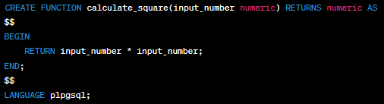
You can then use this function in queries:
Scalar functions are powerful tools for encapsulating complex logic and promoting code reusability in your PostgreSQL database. They are especially useful when you need to apply the same operation to multiple rows or reuse a specific calculation in various parts of your SQL code.

SQL queries:

SQL (Structured Query Language) is a domain-specific language used for managing and querying relational databases. It allows you to interact with databases to perform tasks such as retrieving data, modifying data, creating and modifying database schemas (tables, indexes, etc.), and more. Example:
SELECT, INSERT, UPDATE, ALTER, DELETE, CREATE TABLE, ALTER TABLE, JOIN, GROUP BY, ORDER BY, LIMIT

Foreign keys and primary keys:
Foreign keys and primary keys are essential concepts in relational database management systems (RDBMS). They are used to establish relationships between tables and ensure data integrity. Here's an explanation of each:

1. Primary Key:
- A primary key is a column or set of columns in a database table that uniquely identifies each row or record in that table.
- It enforces entity integrity, ensuring that each record has a unique identifier within the table.
- Primary keys must have unique values for each row and cannot contain NULL values.
- In most cases, primary keys are used as the basis for creating relationships with other tables.
- Primary keys can be single-column or composite (multiple columns combined to form a unique key).

Example: In a "Customers" table, the "CustomerID" column can be used as the primary key because it uniquely identifies each customer.

2. Foreign Key:
- A foreign key is a column or set of columns in a database table that establishes a link or relationship between two tables.
- It creates referential integrity by ensuring that the values in the foreign key column(s) correspond to values in the primary key of another table.
- Foreign keys are used to enforce data integrity and maintain relationships between tables.
- They help maintain consistency in data by preventing actions that would violate the defined relationships, such as deleting a record with related records in another table.
- Foreign keys reference the primary key of another table, creating a parent-child relationship between the two tables.

Example: In an "Orders" table, the "CustomerID" column can be a foreign key that references the "CustomerID" column in the "Customers" table. This establishes a relationship between orders and customers, ensuring that orders are associated with valid customers.

In summary, primary keys uniquely identify rows within a single table, while foreign keys establish relationships between tables by linking to the primary key of another table. These keys are fundamental for maintaining data integrity and modeling complex data relationships in a relational database.

CLOSURE:
In PostgreSQL (often referred to as "psql"), a closure typically refers to a query or subquery that references columns or values from an outer query. This allows you to create complex queries that can access data from different parts of the query hierarchy. Closures are essential for writing efficient and expressive SQL queries.

Here's a simple example to illustrate the concept of closures in PostgreSQL:

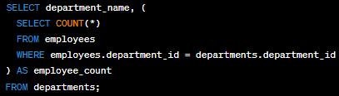
In this SQL query, we have an outer query that selects department names from a "departments" table. Inside the outer query, there's a subquery enclosed in parentheses. This subquery calculates the count of employees in each department by matching the "department_id" from the outer query with the "department_id" in the "employees" table.

The subquery is a closure because it references a column from the outer query (in this case, "department_id"). Without closures, you wouldn't be able to correlate the data from the outer query with the data in the subquery.

Closures are a fundamental aspect of SQL and are used extensively to create complex queries that retrieve and manipulate data from multiple tables or subqueries. They enable you to perform operations like aggregation, filtering, and joining data across different parts of your SQL statements.

TRANSACTIONS:
In PostgreSQL (often referred to as "psql" which is the interactive terminal for PostgreSQL), transactions are a fundamental concept for managing database operations. A transaction is a series of one or more SQL statements that are executed as a single unit of work. Either all the statements in a transaction are executed successfully, or none of them are. Transactions provide data consistency and integrity by ensuring that the database remains in a valid state, even in the face of errors or concurrent access by multiple users.

Here are the basic commands and concepts related to transactions in psql:

1. **BEGIN**: To start a transaction, you use the `BEGIN` command. This marks the beginning of a transaction block.
2. **COMMIT**: To save all the changes made within a transaction and make them permanent, you use the `COMMIT` command.
3. **ROLLBACK**: If something goes wrong within a transaction and you want to discard all the changes made since the beginning of the transaction, you can use the `ROLLBACK` command.
4. **SAVEPOINT**: You can create savepoints within a transaction to mark specific points to which you can later roll back. This is useful for partial rollbacks.
5. **ROLLBACK TO**: If you have created savepoints, you can roll back to a specific savepoint using the `ROLLBACK TO` command.
6. **RELEASE**: To release a savepoint and allow it to be automatically deleted, use the `RELEASE` command.
7. **Autocommit Mode**: By default, psql operates in auto-commit mode, where each SQL statement is treated as a transaction of its own. This means that every statement is automatically committed after execution. To disable auto-commit mode, you can use:
To enable it again, you can use:
Here's an example of a simple transaction in psql:
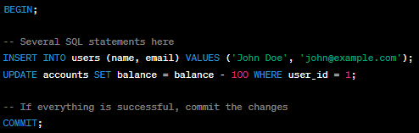
In this example, if any of the SQL statements within the `BEGIN` and `COMMIT` block fails, the entire transaction will be rolled back, ensuring data integrity. Transactions are crucial for managing database consistency, especially in multi-user environments where multiple operations might occur simultaneously.

DDL commands:
In PostgreSQL (often abbreviated as "PSQL"), DDL stands for Data Definition Language. It is a subset of SQL (Structured Query Language) used to define, modify, and manage the structure of database objects. DDL statements are used to create, alter, and delete database objects such as tables, indexes, constraints, and views. Here are some common DDL statements in PostgreSQL:

1. **CREATE TABLE:** This statement is used to create a new table with the specified columns, data types, and constraints.
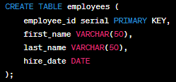
2. **ALTER TABLE:** The ALTER TABLE statement is used to modify an existing table, such as adding, modifying, or dropping columns.
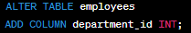
3. **DROP TABLE:** This statement is used to delete an existing table along with all its data.
4. **CREATE INDEX:** Indexes are used to improve the performance of queries. You can create an index on one or more columns of a table.
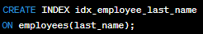
5. **DROP INDEX:** To remove an existing index, you can use the DROP INDEX statement.
DROP INDEX idx_employee_last_name;
6. **CREATE VIEW:** A view is a virtual table based on the result of a SELECT query. You can create views to simplify complex queries or provide a specific perspective on data.
CREATE VIEW employee_names AS
SELECT first_name, last_name
FROM employees;
7. **DROP VIEW:** To delete a view, you can use the DROP VIEW statement.
DROP VIEW employee_names;
8. **CREATE SEQUENCE:** Sequences are used to generate unique integer values, often for primary keys.
CREATE SEQUENCE employee_id_seq;
9. **ALTER SEQUENCE:** The ALTER SEQUENCE statement is used to modify the attributes of a sequence, such as the starting value or increment.

ALTER SEQUENCE employee_id_seq
RESTART WITH 1000;
10. **DROP SEQUENCE:** To delete a sequence, you can use the DROP SEQUENCE statement.
DROP SEQUENCE employee_id_seq;
These are some of the common DDL statements used in PostgreSQL to define and manage the structure of database objects. Keep in mind that DDL statements can have a significant impact on your database schema, so use them carefully and consider taking backups before making structural changes to your database.

DML commands:
DML, or Data Manipulation Language, in PostgreSQL (and other relational database management systems) is a set of SQL (Structured Query Language) statements that allow you to interact with and manipulate data within a database. DML statements are primarily used for querying, inserting, updating, and deleting data in database tables. Here are the main DML statements in PostgreSQL:

1. **SELECT**: The SELECT statement is used to retrieve data from one or more tables in the database. You can specify the columns you want to retrieve and use various clauses like WHERE, JOIN, ORDER BY, GROUP BY, and HAVING to filter and manipulate the data.
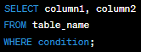
2. **INSERT**: The INSERT statement is used to add new rows of data into a table. You can either insert values explicitly or use a subquery to insert data from another table. 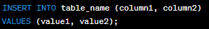
3. **UPDATE**: The UPDATE statement is used to modify existing data in a table. You can specify which rows to update using the WHERE clause.
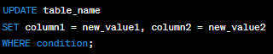
4. **DELETE**: The DELETE statement is used to remove rows from a table based on a specified condition.
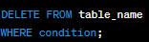
5. **MERGE (UPSERT)**: PostgreSQL does not have a built-in MERGE statement like some other databases, but you can achieve similar functionality using a combination of INSERT and UPDATE statements or by using the ON CONFLICT clause with the INSERT statement.
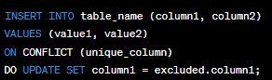
These are the fundamental DML statements in PostgreSQL that allow you to interact with the data stored in your database tables. You can use them to retrieve, insert, update, and delete data as needed to maintain and manipulate your database records.

DCL Commands:
In PostgreSQL, DCL (Data Control Language) commands are used to manage user privileges and permissions within the database. These commands allow you to grant or revoke specific privileges to database objects like tables, views, and sequences. The main DCL commands in PostgreSQL, which you can execute in the `psql` command-line tool or in SQL scripts, include:

1. `GRANT`: This command is used to grant specific privileges to a user or a role on a database object. The basic syntax is as follows:
Here's an example that grants SELECT privilege on a table named "example_table" to a user named "username":
2. `REVOKE`: The `REVOKE` command is used to revoke previously granted privileges. The syntax is similar to `GRANT`:

Example:
3. `ALTER DEFAULT PRIVILEGES`: This command is used to set default privileges for newly created objects within a schema. For example, you can set default privileges for tables, sequences, and other objects.
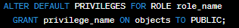
Here, `role_name` is the name of the role for which you want to set default privileges, `privilege_name` is the privilege you want to grant, and `objects` is the type of object (e.g., TABLES, SEQUENCES) for which the default privileges should apply.

4. `SET ROLE`: This command is used to change the current user's role within a session. It allows temporarily adopting the privileges and access rights associated with a different role.
5. `SHOW ROLE`: You can use this command to display information about the current user's role and other roles they have.
6. `RESET ROLE`: To revert to the previous role after using `SET ROLE`, you can use the `RESET ROLE` command.
These are the main DCL commands in PostgreSQL's `psql`. They are crucial for managing security and access control within your PostgreSQL database. Make sure to use them carefully to ensure that users and roles have appropriate permissions while maintaining the security of your data.

Difference between drop and delete and truncate
The DELETE command deletes one or more existing records from the table in the database. The DROP Command drops the complete table from the database. The TRUNCATE Command deletes all the rows from the existing table, leaving the row with the column names.

How to create new user is postgressql?

CREATE DATABASE yourdbname;
CREATE USER youruser WITH ENCRYPTED PASSWORD 'yourpass';
GRANT ALL PRIVILEGES ON DATABASE yourdbname TO youruser;
ALTER USER user_name WITH SUPERUSER;

To login into a particular database:s
psql -U newuser -d mydb
To see the list of users: \du
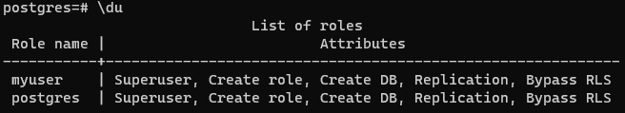

INNER JOIN
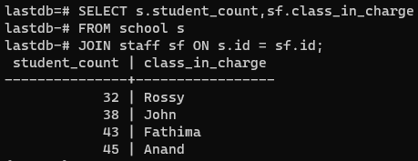

CROSS JOIN
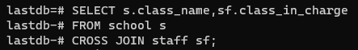

NATURAL JOIN:
Here SQL will decide what is the join condition is. Similar to cross join here also not necessary to mention the join condition.

SELF JOIN:
Joining a table to itself,

